**Chapter I**

**INTRODUCTION**

**Project Context**

Agriculture is a major source of food production to the growing demand of human population and it is the backbone of all developed countries. Before the advent of mechanical equipment, many farming practices were performed by hand, keeping early farmers closely to the land. Currently, some of the irrigation systems are operated manually, farmers visit their agriculture fields periodically and remain present during the irrigation.

A Greenhouses is a structure usually made of glass or clear plastic provides protection and an important part of the agriculture and horticulture sectors in the country as they can be used to grow plants under controlled climatic conditions for optimum produce. The horticulturist in the greenhouse uses direct method or soil sampling. Direct method of measuring soil moisture is not commonly used for irrigation scheduling because it is intrusive and intensive labor and cannot provide immediate feedback.

According to Dr. Cristina David et al, (2015) Agriculture plays a big role in the development of the Philippine economy and attainment of inclusive growth. Irrigation is an important component of the Agricultural system. It raises land productivity by providing sufficient water to crops to increase yield and ensure the stability of production, even under extreme weather conditions. Since technology nowadays is rapidly changing, automation can be used to control systems for operating various equipment. Microcontrollers are typically used for automation due to their highly-programmable platform. Thereby, it eases human work, providing fast communication in terms of receiving and sending accurate information.

Noel T. Florecondia (Southern Leyte State University, Sogod, Southern Leyte Philippines, 2016) design of a Prototype Automatic Plant Irrigation Control System. Farmers

have been using irrigation techniques through manual control. In this automated system, irrigation will automatically take place when there is an intense requirement of water. Automation in irrigation system makes farmer’s work much easier. Sensor-based automated irrigation system provides promising solution to farmers where presence of farmer in the field is not mandatory to perform irrigation process.

In order to overcome this problem, the researchers thought of an idea of Soil Moisture Monitoring with Automated Water Sprinkler, an automatic watering system with android application to monitor the current status of soil moisture level. And a conservation project which can be useful and able to contribute to the farmers/horticulturists and greenhouse environment.

**Purpose and Description of the Project**

The main purpose of “Soil Moisture Monitoring with Automated Water Sprinkler” is to distribute the exact amount of water needed by the plant based on the measured soil moisture level in the field, it can reduce time, effort and eliminate scheduling system for watering the plant. It also manages to contain the pressures of water caused by over-watering plants.

This system determines the soil moisture content and necessity of water to plant in order to distribute the right amount of water to maintain the proper moisture level of the soil. The device will send data to the user once the soil is dry and Arduino Uno a microcontroller that automatically operates the watering of plants.

**Objectives of the Project**

**General Objectives**

The main objective of this research was to develop and implement the proposed study entitled “Soil Moisture Monitoring with Automated Water Sprinkler” in a greenhouse. Specifically, it aimed to:

1. Provide statistic of soil humidity from previous to current;
2. Avoid delay in irrigating the plants;
3. Provide a system that can reduce the workload of horticulturists on monitoring and watering the plant;
4. Determine the problems encountered of the current manual soil moisture monitoring and manual sprinkler irrigation in terms of:
   1. Performance
   2. Information
   3. Economics
   4. Control and Security
   5. Efficiency
   6. Services
5. Evaluate the project entitled Soil Moisture Monitoring with Automated Water Sprinkler in terms of:
   1. Performance
   2. Information
   3. Economics
   4. Control and Security
   5. Efficiency
   6. Services

**Scope and Limitations of the Project**

The project focused solely in developing an automated irrigation system that has a mobile application to record and monitor, and a device that will determine the moisture content of the soil and will trigger the watering system. The availability and usability of the project is indoor/inside of the greenhouse only. The project was intended only in greenhouse for propagation/production of chili.

The android application was installed only on the farmer’s/horticulturist mobile phones for them to view the current status of the soil moisture and it will not be uploaded in App Store. The system focused primarily on soil moisture content as the basis for irrigation system, no other sensor was implemented. Maintenance of the system still required human intervention to keep

irrigation on course. The system was sensitive to weather condition which may interrupt the effectiveness of the Hygrometer Sensor and required manual refill of the water tank to store and establish adequate amount of water enough for irrigation.

**Chapter II**

**REVIEW OF RELATED LITERATURE**

Related literature and studies provide necessary information from articles, books and internet which were used as references in the development of Soil Moisture Monitoring with Automated Water Sprinkler in a greenhouse for the Department of Agriculture, Cauayan City, Isabela.

**Related Literature**

**Foreign**

Naik et al., (2017) In the proposed system, they used various sensors like temperature, humidity, soil moisture sensors that sense the various parameters of the soil. In addition, based on soil moisture value land is automatically irrigated by ON/OFF of the motor. These sensed parameters and motor status were displayed on user-android application.

R. Sujatha, R. Anitha Nithya (2017) surveyed about the using of Internet of Things (IoT) sensors with the cloud environment to testing and monitoring the soil. Testing of soil type and quality consists of many tests, such as bulk density test, respiration test, moisture test and it also needs to check the water quality. In viewing of results obtained by the above tests the device suggests the crop for the farmer and it also helps him for the maintenance of the crop.

Ibrahim Mohd Kassim et al., (2016) Precision Agriculture (PA) used WMSN to enable efficient irrigation. In this paper, the researcher describes about IoT and WMSN in agriculture applications particularly in greenhouse environment. This paper explained and proved the efficiency of feedback control method in greenhouse crop irrigation. A test was conducted to see the different these two methods. The methods are irrigation by schedule or feedback-based irrigation. Irrigation by schedule is to supply water to the plant at specific time periods. Feedback

based irrigation is to irrigate plant when the moisture or level of media wetness reached predefined value. The test shows that there is an average savings of 1,500 ml per day per tree.

Nilesh et al., (2015) used different types of irrigation systems based on GSM. These systems were all remotely controlled systems which proposed a low-cost information exchange via SMS and GSM. The result of the survey conducted has led to a very positive approach on the impact of GSM technology in farm irrigation methods & techniques. Everyday new techniques have been implemented for minimizing the irrigation process like mobile phone and other software application for conduction of irrigation process. This leads to a better and more efficient agricultural development for the future generations to come.

T.C. Meyer et al., (2015) represented the design of smart sprinkler system using mesh capable WSN for monitoring and control of field irrigation system. This system provides accuracy by controlling the soil moisture level between the thresholds. Sensor nodes send data to base station every time the timer variable overflows. Base station has an actuator interface to control solenoid valve using GUI. GUI provides system feedback to user and allows changing the parameter and initially setup the system. Air temperature, soil temperature and humidity greatly influence the tomato crop. Certain disease occurs in tomato crop due to high humidity and warm temperature such as gray mould and leaf mould.

Ravi Kishore Kodali et al., (2015) represented the overall history of spices as black pepper, cardamom and clove in different states where these spices are cultivated and exporters of spices and the problem faced by farming community related to pest and irrigation. Therefore, WSN used to measure different soil and environmental parameter and the presence of pests among crops and provides measures value to the user to take appropriate decision to improve

crop yield. MEMSIC eko nodes used for real time monitoring of parameters and control of irrigation system.

Shaik Ameer et al., (2015) described the use of solar power for an automatic irrigation system to supply required water to the pump set. Solar module used to convert sunlight to electricity. The electricity produced from sunlight can be stored in batteries. Humidity sensors used to sense the wet and dry conditions of the soil. After sense the data, the sensor node sends signal to microcontroller and microcontroller give signals to relay which is an electrically controlled switch for on and off to turn on the motor if the soil is dry and off the motor in wet conditions.

Anuj Nayak et al., (2014) described that sensor nodes batteries are charged by using harnessing wind energy. A routing algorithm named DEHAR is proposed to extend overall batteries power. The proposed method is efficient where the amount of sensor nodes very low because of latency experienced due to synchronous sleep scheduling. A small band belt used to harness wind energy to sensor nodes. Wind belt is aero elastic flutter, which is capable for harnessing wind energy. Harnessing wind energy is a renewable energy source. However, the main problem using harnessing wind energy is the unreliability as the power of the wind is not permanent.

Gao et al., (2014) In this way, a soil moisture classification model based on Support Vector Machine (SVM) with low-cost sensors as a way of substitution for high-cost soil moisture sensors is proposed in this paper to meet the practical needs of agricultural wireless sensor network. Tests results show that the proposed model has good classification accuracy in the same soil environment.

J Call Quer, (2014) “Arduino Uno”, The Arduino Uno is a microcontroller board based on the ATmega328 (datasheet). It has 14 digital input/output pins (of which 6 can be used as PWM outputs), 6 analog inputs, a 16 MHz crystal oscillator, a USB connection, a power jack, an ICSP header, and a reset button. It contains everything needed to support the microcontroller; simply connect it to a computer with a USB cable or power it with a AC-to-DC adapter or battery to get started. The Uno differs from all preceding boards in that it does not use the FTDI USB-to-serial driver chip. Instead, it features the Atmega8U2 programmed as a USB-to-serial converter. "Uno" means one in Italian and is named to mark the upcoming release of Arduino 1.0. The Uno and version 1.0 will be the reference versions of Arduino, moving forward. The Uno is the latest in a series of USB Arduino boards, and the reference model for the Arduino platform. Arduino can sense the environment by receiving input from a variety of sensors and can affect its surroundings by controlling lights, motors, and other actuators. The microcontroller on the board is programmed using the Arduino programming language (based on Wiring) and the Arduino development environment (based on Processing). Arduino projects can be stand-alone or they can communicate with software on running on a computer.

Jovanović, Uglješa et. Al., (2014) The system is modular and consists of a base unit connected to a PC via USB communication and a sensing node based on a Watermark 200SS soil moisture sensor. The system is designed for practical application in agriculture hence the maximal distance between base unit and sensing node in open space is up to 10 km. A proper virtual instrument made in LabVIEW is developed for data acquisition, visualization and data storage. Calibration procedure is presented along with the obtained test results.

Mat, Kassim, & Harun, (2014) described the WSN technology that enabled automated irrigation for precision agriculture (PA) in a greenhouse. In this paper, greenhouse monitoring used to monitor temperature, humidity and soil moisture parameter. Data collected from sensors send to

remote server for analysis. Based on threshold value of moisture data, automated irrigation value control operation performs. Using sensor automated integrated information technology and management; PA used to improve the product quality and efficient of crop chemical use. Result shows that automatic irrigation is better than scheduled irrigation because it optimizes the use of water and fertilizer and maintains soil moisture.

**Local**

Jaina Nica et al., (Computer Engineering Department, Lyceum of the Philippines University – Laguna, October 2016) Design and Implementation of Smart Farm Data Logging and Monitoring System. These four Parameters, which needs to be observed, include temperature, humidity, soil moisture content, and acidity of the soil as well. This system will be simulated and executed using microcontroller specifically Arduino ATMega 2560, which serves as the main control unit that is suitable for integrating the said sensor for monitoring the data parameters.

Jomar S. Vitales et al., (College of Engineering and computing sciences, Batangas State University ARASOF Nasugbu, Batangas Philippines 2015). Portable Water Level Monitoring System via SMS developed to warn people about the water level of the river. There are three levels of warning. The minor level, Moderate and major level. When water level reaches different minor level sensor, the device will send SMS that you need to stay at home, prepare for evacuation and evacuate immediately.

J C Pagatpat et al., - Mindanao-State University-Ilagan Institute of Technology Iligan City, Philippines (2015) GSM & web-based flood monitoring system. They develop flood detection, emergency alert and Monitoring system which warn the residents of a particular community for possible flooding along the mandulog river banks, the water level detection device which has a GSM kits will send to server node.

Edmond B. Ecija et al., (Electronics Engineering Department Lyceum of the Philippines University-Laguna, September 2015) Automatic Soil Moisture Sensing Water Irrigation System with Water Level Indicator. The proposed system uses a microcontroller basically a platform device called ARDUINO where Sensors are connected in its internal and external ports. This irrigation system also includes a water level Indicator in the water tank which will indicate the water capacity of the reservoir itself whether it is low Level or high level. Water level indicator also its pumping system that aims to deliver the needed water based on the assigned soil moisture value.

Vergara & Villaruz, (2014) “Development of an Arduino-based automated household utility power monitoring system”. This work develops an automated household utility power monitoring system and data logging in real-time. It utilizes the Arduino Uno Rev3 Microcontroller board intended for use in conjunction with the ATmega328 chip. For monitoring these parameters, it will be connected to a current transformer through the current and voltage sensor circuit. The system will convert these raw data to digital input for data acquisition and will log these to an SD card by the SD/MMC shield module for data retention in case of power failures. The system is also equipped with DS1307 serial RTC (Real-Time Clock) chip which is responsible for providing real time clock and date needed in the data logging operation. Results and findings indicated that the device has indeed successfully performed its desired function as an automated household utility power monitoring system. As such it will display in real-time, the consumed average power in watt along with its price. This will serve as an assessment parameter in order to measure the acceptability, performance relative to functionality, and marketability of the accomplished technology.

Ruvel J. Cuasito, Sr. (2013) “Design, Development and Implementation of Educational and Entertainment Mobile Robots Utilizing Arduino Microcontroller”. The Arduino-based mobile

robots were responsive to the control design truth table specified in varied prototype featured bearing the input and output components installed. The line sensors which are generally made of reflective sensors responded efficiently to the logical algorithm and effectively influence the motor rotation and physical motion of the mobile robots. Object sensors which are made of ultrasonic sensors also responded efficiency in accordance to the programmed distance detection range. The ultrasonic signals provide appropriate rotational direction of the prime movers.

**Related Studies**

**Foreign**

Udupa et al., (2015) the Arduino board and soil moisture sensor-based irrigation system. The Present system is a model to modernize the agriculture industries at a mass scale with optimum expenditure. An automated irrigation model is designed and implemented this model considering low cost, Reliability, and automatic control. As the proposed model is automatically controlled it will help the Farmers to properly irrigate their fields.

Joaquin Gutierrez et al., (2015) represented the sensors used Smartphone to capture and process images of soils. Images can be capture to estimate the water content of the soil. The router node is used to forward collected values to the gateway that provide automatically pump the water to the crop in a field. An Android app used for connectivity such as Wi-Fi. Android app wakes up the Smartphone by using given parameters. In-built camera takes an RGB picture of the soil through an anti-reflective glass window to take estimation of wet and dry area. The mobile app enables the Wi-Fi connection of Smartphone to transmit the estimation value to the gateway via a router node for control an irrigation water pump.

Chaitali et al., (2014). The Microcontroller and soil moisture sensor-based irrigation system proves to be a real time response control system which monitors and wheel all the

activities of irrigation system. The present system is a model to modernize the agriculture industries ata mass scale with optimum expenditure. An automated irrigation model is proposed using different circuits as demonstrated in different figures. We designed and implemented this model considering low cost, reliability, alternate source of electric power and automatic control. As the proposed model is automatically controlled it will help the farmers to properly irrigate their fields. The model always ensures the sufficient level of water in the paddy field avoiding the under-irrigation and over-irrigation they can provide irrigation to larger areas of plants with less water spending and inferior pressure. Using this system, one can save manpower, water to get better manufacture and eventually income. Advanced soil moisture level sensor will use in these we can measure different parameter that is pressure, temperature and humidity, of soil. Different amount of water requirements for different types of soil in this according to the type of crop, and water resistance capacity in different seasons, system provide definite amount of water to the plant hence, we can save large amount of water.

Nattapol Kaewmard et al., (2014) described the design of an automated irrigation system using WSN including soil moisture sensor, air temperature sensor and air humidity sensor in order to collect environmental data and controlling the irrigation system. By using smart phone, the irrigation system uses values to turn on/off the solenoid valve. The irrigation system control water by sending and receiving control commands from smart phone application via the internet. Result shows that proposed AIS is useful, cost effective and provides better performance than conventional system.

**Local**

Aguilar, R. B. et al., (2017) “Automatic Soil Moisture Sensing Water Irrigation System with Water Level Indicator”. The proposed system uses an ARDUINO Uno that simplifies the

working of microcontroller programming compared to other programming tools. Whenever there is a variation in moisture content of the soil these sensors will determine the change and will give an interrupt signal to the microcontroller and eventually will send signal to the relay driver that will activate the water pump. This irrigation system also includes a water level indicator in the water tank which will indicate the water capacity of the reservoir itself whether it is low level or high level.

Abaya, S. et al., (2017) “A self-activating irrigation technology designed for a smart and futuristic farming”. The “smart” farming tries to attract Filipinos to be involved in agriculture by opening a window on how the old-aged practice of farming integrates the application of modern technologies. Catalyzing a device embedded with sensor technologies such as the soil moisture sensor that can identify the water volume content of soil which when incorporated in the irrigation management strategy may result in the conservation of costly water irrigation, a humidity sensor that can descry dry presence of water in air and a self-activating irrigation that will release enough amount of water needed by the soil for cultivating healthy plants.

Majiah Collado, Jefferson Jr. Ramos Vallente (Xavier University – Ateneo de Cagayan, 2016) Soil pH Mapping System. The research was tested for the case of an agricultural land at Manresa Farm of Xavier University, Cagayan de Oro city using combination of Geographic Information System (GIS) techniques and PH data collection through a soil pH sensor. Soil pH level of the soil samples were conducted at the Laboratory setup both using the research prototype and laboratory digital pH meter wherein the prototype comprises a pH meter and a microcontroller.

Noel T. Florecondia (Southern Leyte State University, Sogod, Southern Leyte Philippines, 2016) Design of a Prototype Automatic Plant Irrigation Control System. Farmers

have been using irrigation Techniques through manual control. In this automated system, Irrigation will automatically take place when there is an intense requirement of water. As suggested by its moisture content and will automatically turn oﬀ when the soil ﬁnally received the amount of water it needs. The testing of the device under diﬀerent soil conditions was interpreted based on the sensor input value of the microcontroller.

**Chapter III**

**TECHNICAL BACKGROUND**

The project entitled “Soil Moisture Monitoring with Automated Water Sprinkler” used Arduino Uno, Hygrometer, SIM900A GSM module, Relay module, water sprinkler and android mobile phone to automate the manual process in monitoring soil moisture. Sprinkler Irrigation Arduino Uno and Hygrometers were utilized in monitoring the moisture content of the soil.

**Technicality of the Project**

This chapter discussed the technicality of the project, described the type of the project to be developed and its functionality, and represented the kind of application used in the development.

**Details of the technologies to be used**

During the development stage, the software, hardware, and people ware requirements for this research were the following:

**Development**

**Table 1.** Hardware and software that were used during the development.

|  |  |
| --- | --- |
| **Hardware** | **Software** |
| * Arduino UNO * Hygrometer sensor * Sim900a GSM module * Relay module * Jumper wires * Water sprinkler * DC solenoid water Valve 12V * Battery 12V * Water motor pump 12V * Android mobile phone * Android 8.0 * Computer * Processor – Intel Celeron * Memory – 4GB * Hard Disk – 500GB | * Android studio * SQLite * Arduino * Adobe photoshop CS6 * Operating system – Windows 8.1 |

**Implementation**

**Table 2.** Hardware and software that were used during the implementation.

|  |  |
| --- | --- |
| **Hardware** | **Software** |
| * Arduino UNO * Hygrometer sensor * SIM900A GSM module * Relay module * Jumper wire * Water sprinkler * Solenoid water valve 12V * Battery 12V * Water motor pump 12V | * Android Mobile Application |

**People ware**

Farmer’s must have to use android mobile phone in monitoring the current and previous soil moisture data including the total of irrigations per day that being transmitted by the device through SMS.

**How the project will work**

This study aims to design and develop a system for monitoring the soil moisture content then automatically irrigate the plant. A microcontroller that automatically operates the system along with the Hygrometer sensor that processes and collects data from the soil. GSM that transmit data to the user’s application. Relay module for controlling the electricity that goes to solenoid valve. Solenoid valve which is responsible for allowing and blocking of water that flows to water pump and water sprinkler for the distribution of water to the plants. And a mobile application for viewing all the record that comes from the device.

**Chapter IV**

**METHODOLOGY**

This chapter deals with the type of research used by the proponents in developing the “Soil Moisture Monitoring with Automated Water Sprinkler”. It describes the methods used and to whom the system was developed.

**Environment**

**Locale**

The study was conducted in the Department of Agriculture Greenhouse located at Cabaruan, Cauayan City, Isabela.

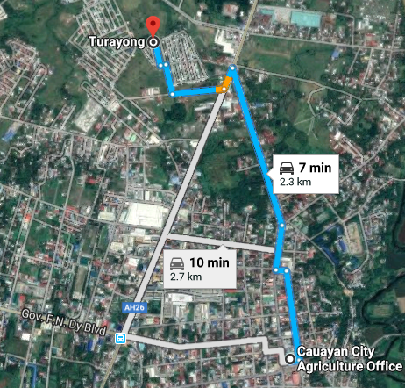

***Figure 1: Location of the respondents***

**Population of the Study**

**Table 3. Population of the Study**

|  |  |  |
| --- | --- | --- |
| **Respondents** | **No. of Respondents** | **Percentage** |
| Department of Agriculture - LGU  Greenhouse, Cabaruan, Cauayan City, Isabela | 4 | 40% |
| Office of the Department of Agriculture – LGU, Cauayan City, Isabela | 6 | 60% |
| **Total** | **10** | **100%** |

Table 3 shows the respondent distributions. There are 4 respondents from DA-LGU Greenhouse, Cabaruan, Cauayan City, Isabela and 6 Respondents from the Office of DA-LGU, Cauayan City, Isabela.

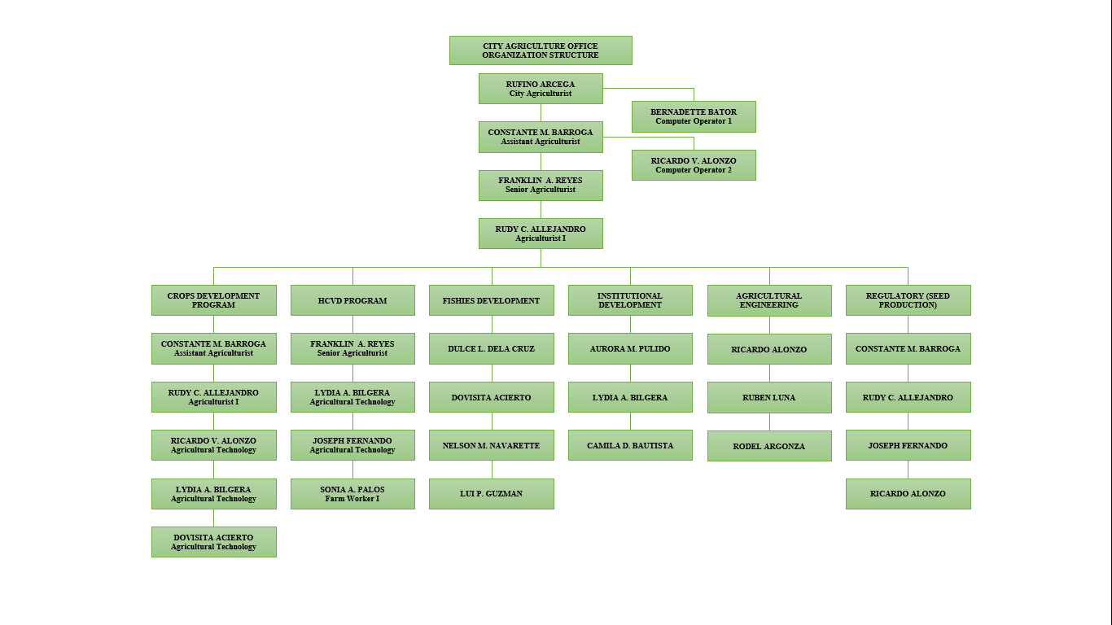**Organizational Chart/Profile**

***Figure 2: Organizational Chart***

**Software Development Methodology**

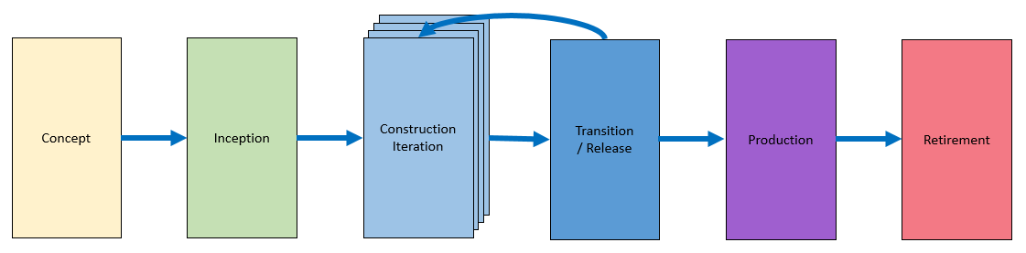 The researchers used the agile software development life cycle because it is easy to understand by the users. It shows the step by step procedure on the system development.

***Figure 3: Agile Software Development Life Cycle***

**Phase 1: Concept**

The researchers identified and prioritized potential project; developed initial vision; and considered project feasibility on how the application was developed.

**Phase 2: Inception**

In this phase, the researchers determined requirements using flowchart and created timeline to finish the application to develop including database structure, user interface of application and device interface.

**Phase 3: Construction/Iteration**

In this phase, the researchers began to work on first iteration to develop the application and program the device based on their functions needed. Various revision was applied to meet function needed by user.

**Phase 4: Release**

In this phase, the researchers tested the application and device using alpha testing and beta testing, where in the alpha testing was done by developers or those who were part of the

project. Meanwhile, the beta testing was tested by users or those who were not part of the project. The researchers demonstrated the application and device flow to the user in order to understand the functions and deploys into production.

**Phase 5: Production**

After the release phase was done, the user operated and identified defects and enhancement of the application and device.

**Phase 6: Retirement**

The retirement phase may apply if there is an innovation or new development to the application and device that may use to monitor the current and previous soil moisture data and automatically irrigate the plant.

**Research Design**

The researcher made use of the descriptive method of research to describe the effectiveness of Soil Moisture Monitoring with Automated Water Sprinkler in terms of design, content, performance and functionality.

**Data Gathering Procedure**

The researchers used observation method, interview, questionnaire, library-based research, and surfing the internet to gather the data. The researcher uses appropriate data gathering instruments or method in order to obtain the needed information essentials in their study.

**Observation**

The observation method was where the researchers did observation, writing notes and audio or video recording the information needed in the study. This could be very useful method in the analysis process.

**Interview**

This method was utilized by the researchers in the beginning of the study. The researchers interviewed the city agriculturist and some employees of City of Agriculture, Cauayan City to determine the current problem encountered in their greenhouses.

**Questionnaire**

The researchers visited respondents in their workplace, and printed form that contains a list of questions answered by the respondents. The researchers used it to gather information needed to find out the status, efficiency and the problems encountered.

**Library Research**

This method involves step-by-step process used to gather information in order to write a complete project. The researchers used this method in defining terms in the study that serves as guidelines in writing research analysis from similar analysis procedures.

**Internet-based research**

Internet-based research is a new method in collecting information, topic, and related studies. The researchers surfed the internet for the analysis and better understanding of the study.

**Research Instrument**

The researchers used survey-questionnaire as the main data-gathering tool. Questions were formulated to determine the opinion, recommendation and suggestions from the respondents to enhance the proposed system.

**Table 4. Likert Scale Shows the Weighted Mean Range of the Pre-survey and its Descriptive Interpretation as Evaluated by the Respondents.**

|  |  |
| --- | --- |
| **Weighted Mean Range** | **Descriptive Interpretation** |
| 4.20 - 5.0 | Very Much of a Problem |
| 3.40 - 4.19 | Much of a Problem |
| 2.60 - 3.39 | Problem |
| 1.80 - 2.59 | Less of a Problem |
| 1.00 - 1.79 | Least of a Problem |

**Table 5. Likert Scale Showed the Weighted Mean Range of the Post Survey and its Descriptive Interpretation as Evaluated by the Respondents.**

|  |  |
| --- | --- |
| **Weighted Mean Range** | **Descriptive Interpretation** |
| 4.20 - 5.0 | Strongly Agree |
| 3.40 - 4.19 | Agree |
| 2.60 - 3.39 | Fairly Agree |
| 1.80 - 2.59 | Disagree |
| 1.00 - 1.79 | Strongly Disagree |

**Requirements Specifications**

**Operational Feasibility**

The researchers used the Ishikawa or fishbone diagram to depict the cause and effect of the various affecting the effectiveness of the manual monitoring of soil moisture and irrigating the plant.

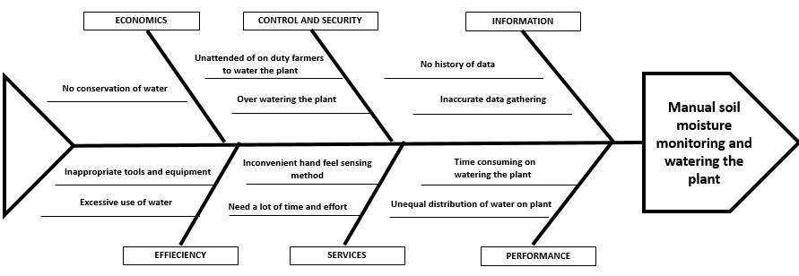**Fishbone Diagram**

***Figure 4: Fishbone Diagram***

Figure 4 presents the factors that affect the effectiveness of the manual monitoring of the moisture content of the soil and manual irrigation of plants. In some cases, the monitoring of moisture content of the soil is time-consuming and sometimes farmers forget to irrigate the plants due to performing other works. Aside from that, manually irrigating plants have a high possibility to drown the plants, because of the inadequate devices of the greenhouse. Sunny weather highly affects the soil that needs to water regularly.

**Functional Decomposition Diagram**

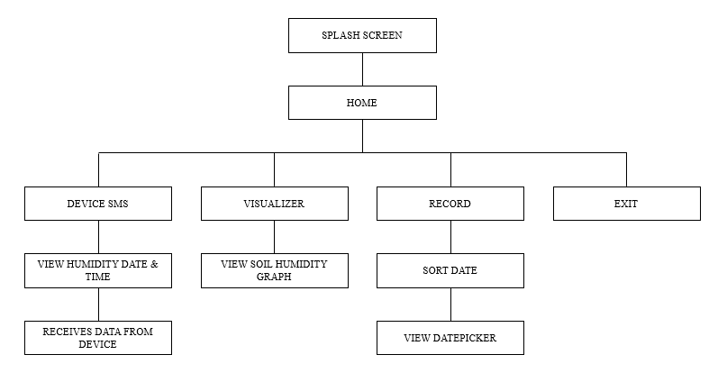

***Figure 5: Functional Decomposition Diagram***

Figure 5 presents the relation between layouts and where the data come from. From Layout Splash Screen to different categories and its sub- categories down to exit.

**Technical Feasibility**

**Compatibility Checking** (hardware/ software and other technologies)

**Table 6. Compatibility Checking of Hardware.**

|  |  |
| --- | --- |
| Computer Specifications: | |
| Memory | At least 4 GB |
| Hard Disk | At least 500 GB |
| Processor | At least Intel Celeron |
| System Type | 64-bit Operating System, x64-based Processor |
| Devices | |
| Hygrometer  Arduino Uno  GSM Module  Relay Module  Water Sprinkler  Water Valve  Battery 12 V  Water Motor Pump  Computer  Android Mobile Phone | |

**Table 7. Compatibility Checking of Software.**

|  |  |
| --- | --- |
| Computer Specifications: | |
| Operating System | At least Windows 8.1 |
| Android Studio  SQLite  DB browser for SQLite  Arduino | |

**Relevance of the technologies**

**Table 8. Relevance of the technologies.**

|  |  |
| --- | --- |
| **Hardware Configuration:** | |
| Processor: | Intel Celeron |
| RAM | 4.00 GB |
| Hard Disk | 500 GB |
| System Type | 64-bit Operating System |
| **Software Configuration** | |
| Operating System | Windows 8.1 |
| Programming Language | Arduino & Java |
| Database | SQLite |

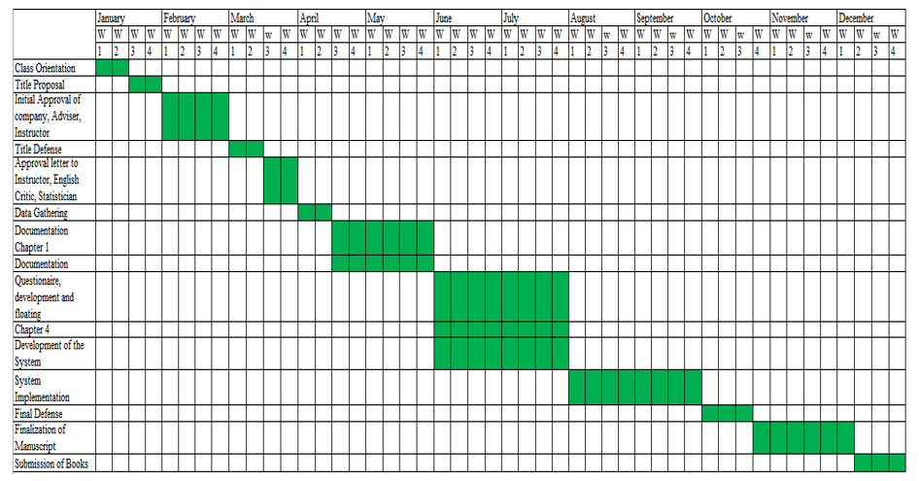**Schedule Feasibility**

**Gantt Chart**

***Figure 6: Gantt Chart***

Figure 6 displays the organized schedules in developing the Soil Moisture Monitoring with Automated Water Sprinkler. The table serves as a guide to the proponents to complete the project.

**Economic Feasibility**

**Cost and Benefit Analysis**

**Table 9.** **List of materials of the proposed system**

|  |  |
| --- | --- |
| **ITEM** | **COST** |
| Arduino Uno | ₱500.00 |
| Hygrometer | ₱450.00 |
| Relay Module | ₱372.00 |
| GSM SIM900A | ₱400.00 |
| Water Sprinkler | ₱829.00 |
| DC Solenoid Water Valve | ₱370.00 |
| 12V Battery | ₱450.00 |
| Water Motor Pump | ₱250.00 |
| Jumper Wires | ₱165.00 |
| Sim Card | ₱40.00 |

The cost of materials needed is worthy enough for the advantages. It fastens the workload of farmers

**Requirements Modeling**

PROCESS

INPUT

Soil Moisture Monitoring with Automated Water Sprinkler

Hygrometer

Arduino Uno

GSM Module

Relay Module

Water Sprinkler

Water Valve

Battery 12 V

Computer

Android Mobile Phone

FEEDBACK

OUTPUT

Agile Method

Concept

Inception

Construction Iterations

Transition/Release

Production

Retirement

***Figure 7: INPUT, PROCESS and OUTPUT MODEL***

Figure 7 shows the input, process and output model wherein there is a need to develop and implement a Soil Moisture Monitoring with Automated Water Sprinkler using Arduino Uno and Hygrometer with Android Mobile Application. It shows the importance and the uses of the system.

**Data and Process Modeling**

**Context Diagram**

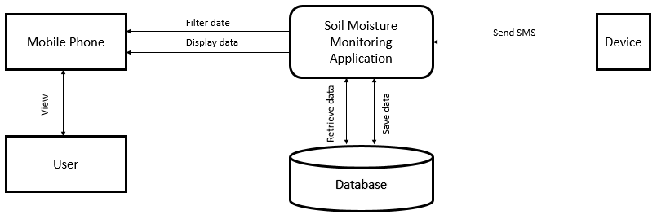

***Figure 8: Context Diagram***

Figure 8 presents how the system works on sending and receiving collected data. The device is collecting data then automatically transmit it to the system. Farmer’s receives the collected data from the device.

**Data Flow Diagram**

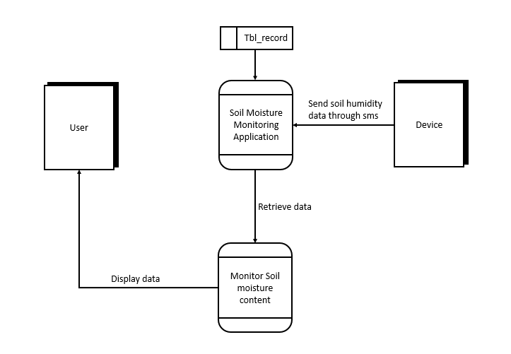

***Figure 9: Data Flow Diagram***

Figure 9 shows the flow of the project. The device monitors the water content of the soil and sends collected data to application then saves to the database. The data will be displayed and can be viewed by the user.

**System Flowchart**

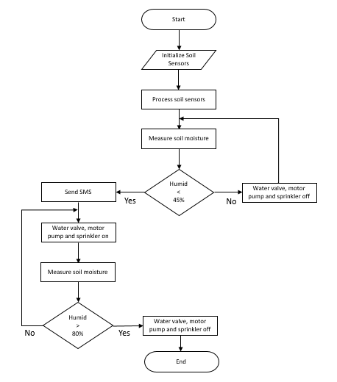

***Figure 10: Device Flowchart***

Figure 10 shows the flowchart of the system’s device. First, the device initializes the soils sensors and measures the soil humidity. When the soil humidity reaches the given condition measure of dryness, it will send SMS to user and triggers the water valve, motor pump and water sprinkler to water the plant. When the soil sensor measures the exact humidity the water valve, motor pump and water sprinkler will turn off.

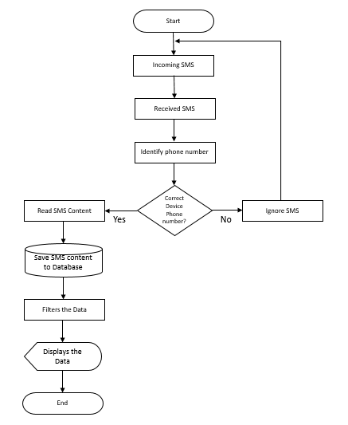

***Figure 11: Android Mobile Application Flowchart***

Figure 11 shows the flowchart of the system’s application. The application will receive SMS from the device, when the phone number is correct it will automatically save the data to the database and displays the data on application.

**Program Flowchart**

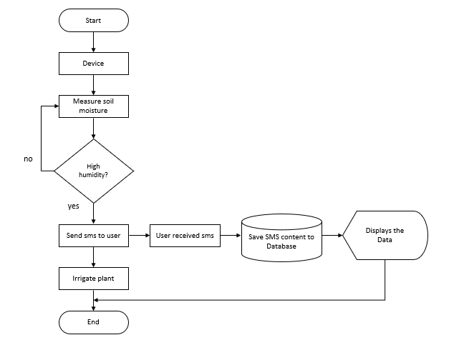

***Figure 12: Program Flowchart***

Figure 12 presents the device measuring the soil moisture content when the soil is dry it irrigates then sends SMS to the user. The received SMS will save to the database. The data will be displayed and viewed by the user.

**Risk Assessment / Analysis**

**Table 10. Risk Assessment / Analysis.**

|  |  |  |  |
| --- | --- | --- | --- |
| **Project Potential Threats** | **Cause** | **Level of Risk** | **Preventive Measures** |
| Hardware Malfunction | Over using of hardware parts | 5 | Consistent checking of hardware parts |
| Software Malfunction | Hardware quality, Deterioration of software | 5 | Consistent checking of software |
| User error | User do not have idea or knowledge of the system | 2 | User training, distribute user’s manual |
| Blackouts | Naturals | 2 | Generate power |

The risk assessment/analysis table shows the potential threats, cause, level of risk and its preventive measures of the project. This will help to identify possible problem, estimate risk, manage and avoid the risk in the system.

**Design**

Output and User-Interface Design

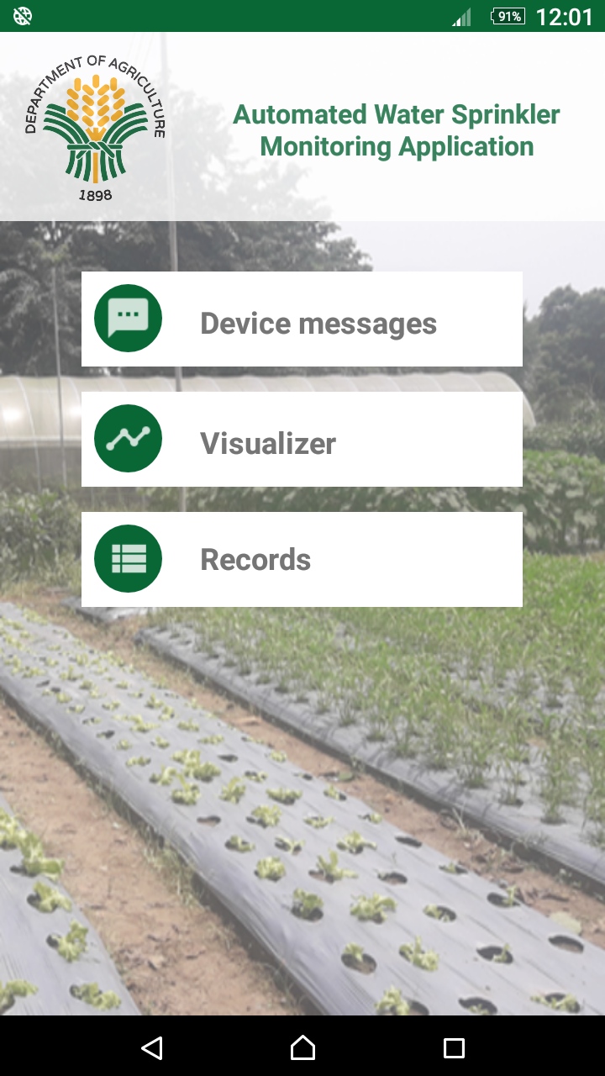

***Figure 13: Home***

Figure 13 displays the menu of the application, where you can choose the transaction of application.

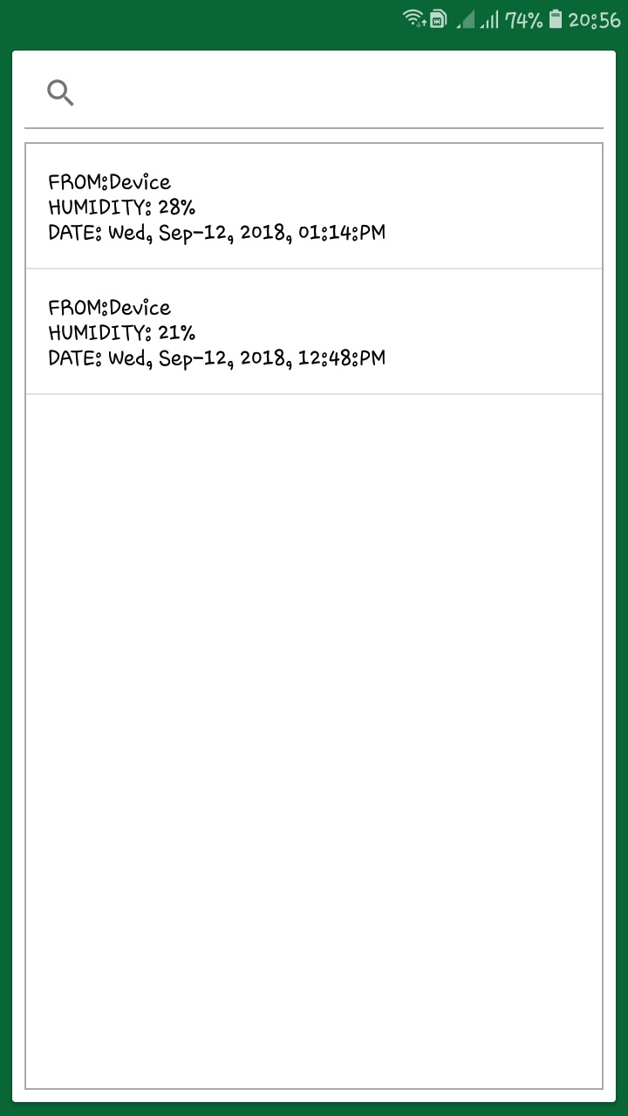

***Figure 14: Device SMS***

Figure 14 displays the receiving of data from the device. It contains the name of the device, percentage of the humidity, date and time when it receives.

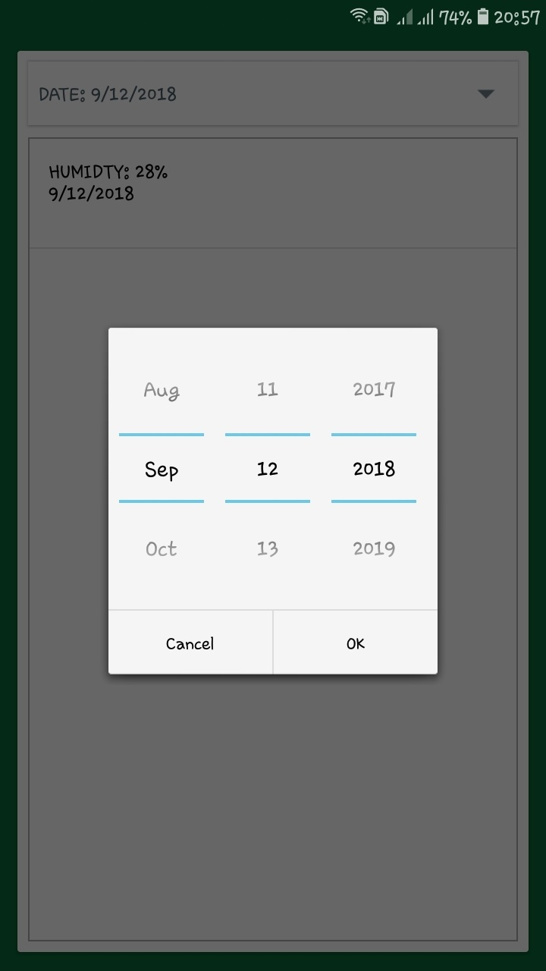

***Figure 15: Records***

Figure 15 displays the list of the previous and current soil moisture content on the given date.

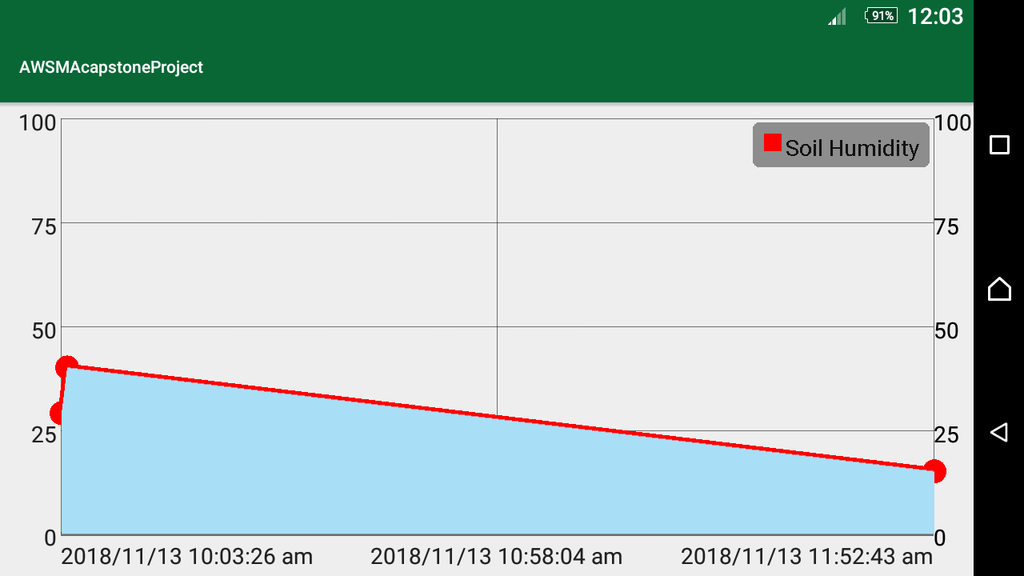

***Figure 16: Visualizer***

Figure 16 displays the record sends by the device based on date, time and the soil humidity using line graph.

**Data Dictionary**

**Table 11. Table Record.**

|  |  |  |  |  |  |
| --- | --- | --- | --- | --- | --- |
| **FIELD**  **NAME** | **DATA**  **TYPE** | **NOT**  **NULL** | **PRIMARY**  **KEY** | **AUTO**  **INCREMENT** | **UNSIGNED** |
| List Humidity | String |  |  |  |  |
| List Date | String |  |  |  |  |

Table 11 presents the data dictionary of record, which shows the received data from the device.

**System Architecture**

**Network Model**

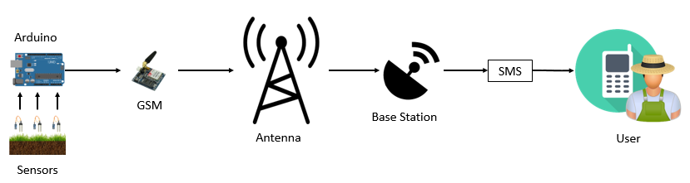

***Figure 17: Network Model***

Figure 17 shows the arrangement of the system network. Sensors are connected to Arduino Uno to process the collected data. GSM will carry the collected data and pass it to antenna. Base station will verify the data then send SMS to the user.

**Network Topology**

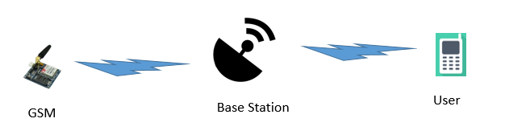

***Figure 18: Network Topology***

Figure 18 shows the wireless networking. This describes the connection of the device and user. The device transmit data without using any network cable.

**Security**

The proposed Soil Moisture Sensor with Automated Water Sprinkler is secured, because the application is installed only on the farmer’s android mobile phone. Only farmers in the greenhouse has the authorization to view the record of the system into the android mobile application.

**Development**

**Software Specification**

**Table 12. Software Specification.**

|  |
| --- |
| Arduino |
| Android Studio 3.2.1 |
| SQLite |
| DB browser for SQLite |
| Microsoft Windows 8.1 |
| Photoshop CS6 |

**Hardware Specification**

**Table 13. Hardware Specification.**

|  |  |
| --- | --- |
| **Laptop** | |
| Brand name and model | Dell Inspiron 3543 |
| Processor | Inter(R) Celeron(R) 3205U @ 1.50GHz |
| Installed Memory (RAM) | 4.00 GB |
| System Type | 64-bit Operating System, x64-based processor |
| Operating System | Windows 8.1 |
| **Android Mobile Phone** | |
| Brand name and model | Samsung Galaxy J7 Core |
| Android version | 8.1.0 |
| Operating System | Oreo |
| **Devices** | Arduino Uno  Hygrometer sensor  GSM Module  Relay Module  Water Sprinkler  Water Valve  Battery 12 V  Water Motor Pump |

**Program Specification**

The researchers used java programming within Android Studio to develop the android application. Android studio is a software used to develop Android apps and to emulate them. Android Studio is exclusively developed to make and run Android apps.

The Arduino Programming Language was used to program the device (based on Wiring) and Arduino development environment (based on Processing). Arduino is an open-source electronics platform based on easy-to-use hardware and software.

**Programming Environment**

**Front End**

The researchers used Android studio as a primary software for developing the android application. The researchers had chosen this integrated development environment, because the researchers could keep working on the same project on the stable version.

**Back End**

The researchers used SQLite as back end of the android application. SQLite is a specialized database for mobile apps. SQLite is an open source database which helps the user to store data. This database is light weighted and available in all the Android Devices. DB Browser for SQLite is a high quality, visual, open source tool to create, design, and edit database files compatible with SQLite.

**Testing**

This process defines the performance of the proposed Soil Moisture Monitoring with Automated Water Sprinkler in terms of accuracy and functionality. Series of test and test cases performed by the researchers to ensure the capability of the system is performing well.

**Unit Testing**

The researchers used unit testing in order to ensure that their design and code works before writing the next piece of code. This improves design and allows better refactoring of code. Also prevents the error that may affects the whole program.

**Integration Testing**

The researches performed integration testing to expose the defects in the interfaces and in the interactions between integrated components. This method is to test the whole flow of the system to identify if it really working properly.

**Compatibility Testing**

The developed android application can install and run on android mobile phones with the features of SMS, Storage and Operating system of 5.0 or higher.

**Performance Testing**

The test of measures the humidity of the soil. The researchers used dry and wet soil in order to measure the humid of the soil. The researchers used the serial monitor of Arduino to see the output data. The result is accurate rather than using the hand feel method.

**Stress Testing**

The researchers performed stress testing, the microcontroller was set to send data every second when the soil was dry and the android app was receiving too much data that causes spamming/redundant on saving to the database. The researchers rewrote the program that the device would send only once to the android app for better viewing the data.

**Loading Testing**

This type of test measures how fast the system responds. The researchers tested how fast the device transmits the data and loading time of the android application. The result of sending data into android application is depends on signal strength of the network and loading time of the android application is fast.

**System Testing**

The system testing was done by Alpha and Beta testing wherein the Alpha testing is done during the development of the system. If the researchers encountered some errors, the researchers would make some various code of modifications to improve and to solve the issue. After the Alpha testing, the Beta testing begins, wherein other persons used the system. Some gave suggestions or recommendation to improve the system.

**Acceptance Testing**

After the alpha, beta testing and the oral presentation of the system, the researchers and users intended to review and analyze the system due to some constraints. The comments and suggestions added for the modification and accepted.

**Chapter V**

**DISCUSSION OF RESULTS**

This chapter includes the presentation, analysis and discussion of collected data through a survey questionnaire using the Likert’s Scale.

**Table 14. Weighted Mean and Descriptive Interpretation of the Respondents on the Problems Encountered of the Manual Soil Moisture Monitoring and Manual Sprinkler Irrigation in Terms of Performance.**

|  |  |  |
| --- | --- | --- |
| **Performance** | **Weighted Mean** | **Descriptive Interpretation** |
| 1. Regular monitoring of moisture content of the soil. | 3.50 | Much of a Problem |
| 1. Plants Schedule of irrigation using current process. | 3.80 | Much of a Problem |
| 1. Distribution of water to plants using manual sprinkler irrigation. | 3.80 | Much of a Problem |
| 1. Day-to-day Accessibility of water transmission. | 3.90 | Much of a Problem |
| 1. Proper Irrigation and timing. | 3.70 | Much of a Problem |
| **Category Mean** | **3.74** | **Much of a Problem** |

Table 14 indicates that “Day-to-day Accessibility of water transmission” obtained the highest weighted mean of 3.90 interpreted as “Much of a Problem.” While “Regular monitoring of moisture content of the soil” obtained the lowest weighted mean 3.50 interpreted as “Much of a Problem.”

The analysis specifies the problems encountered of the current manual process in terms of performance shows “Much of a Problem” under descriptive interpretation with a category mean of 3.74.

**Table 15. Weighted Mean and Descriptive Interpretation of the Respondents on the Problems Encountered of the Manual Soil Moisture Monitoring and Manual Sprinkler Irrigation in Terms of Information and Data.**

|  |  |  |
| --- | --- | --- |
| **Information and Data** | **Weighted Mean** | **Descriptive Interpretation** |
| 1. Accurate data of the soil using feel method. | 3.80 | Much of a Problem |
| 1. Provide immediate information and data of soil. | 3.70 | Much of a Problem |
| 1. Previous information and data of the soil. | 3.70 | Much of a Problem |
| 1. Interpretation of information and data. | 3.90 | Much of a Problem |
| 1. Calculation of watering average per day. | 3.80 | Much of a Problem |
| **Category Mean** | **3.78** | **Much of a Problem** |

Table 15 presents the “Interpretation of information and data” gained the highest weighted mean of 3.90 interpreted as “Much of a Problem.” While “Provide immediate information and data of soil” and “Previous information and data of the soil” gained the lowest weighted mean 3.70 respectively interpreted as “Much of a Problem.”

The analysis specifies the problems encountered of the current manual process in terms of information and data shows “Much of a Problem” under descriptive interpretation with a category mean of 3.78.

**Table 16. Weighted Mean and Descriptive Interpretation of the Respondents on the Problems Encountered of the Manual Soil Moisture Monitoring and Manual Sprinkler Irrigation in Terms of Efficiency.**

|  |  |  |
| --- | --- | --- |
| **Efficiency** | **Weighted Mean** | **Descriptive Interpretation** |
| 1. Appropriate tools and equipment for irrigation. | 4.10 | Much of a Problem |
| 1. Plant growth outcome using feel method in monitoring soil moisture content of the soil and manual irrigation. | 4.0 | Much of a Problem |
| 1. Time consuming by using feel method in monitoring moisture content and manual irrigation. | 3.90 | Much of a Problem |
| **Category Mean** | **4.0** | **Much of a Problem** |

Table 16 indicates that “Appropriate tools and equipment for irrigation” gathered the highest weighted mean of 4.10 interpreted as “Much of a Problem.” While “Time consuming by using feel method in monitoring moisture content and manual irrigation” gathered the lowest weighted mean 3.90 interpreted as “Much of a problem.”

The analysis specifies the problems encountered of the current manual process in terms of efficiency shows “Much of a Problem” under descriptive interpretation with a category mean of 4.0.

**Table 17. Weighted Mean and Descriptive Interpretation of the Respondents on the Problems Encountered of the Manual Soil Moisture Monitoring and Manual Sprinkler Irrigation in Terms of Control and Security.**

|  |  |  |
| --- | --- | --- |
| **Control and Security** | **Weighted Mean** | **Descriptive Interpretation** |
| 1. Using feel method as a requirement to apply water in plants. | 4.30 | Very Much of a Problem |
| 1. High possibility of drowning plants in manual irrigation. | 4..0 | Much of a Problem |
| 1. 3Administering moisture content monitoring of the soil and irrigation. | 4.10 | Much of a Problem |
| 1. Random types of irrigation in propagation of plants. | 3.90 | Much of a Problem |
| **Category Mean** | **4.07** | **Much of a Problem** |

Table 17 shows that “Using feel method as a requirement to apply water in plants” got the highest weighted mean of 4.30 interpreted as “Very Much of a Problem.” While “Random types of irrigation in propagation of plants” got the lowest weighted mean 3.90 interpreted as “Much of a Problem.”

The analysis specifies the problems encountered of the current manual process in terms of control and security shows “Much of a Problem” under descriptive interpretation with a category mean of 4.07.

**Table 18. Weighted Mean and Descriptive Interpretation of the Respondents on the Problems Encountered of the Manual Soil Moisture Monitoring and Manual Sprinkler Irrigation in Terms of Economics.**

|  |  |  |
| --- | --- | --- |
| **Economics** | **Weighted Mean** | **Descriptive Interpretation** |
| 1. Cost of tools and equipment in irrigation. | 4.30 | Very Much of a Problem |
| 1. Manpower efforts in monitoring soil moisture content and irrigating plants. | 4.0 | Much of a Problem |
| 1. Environmental effects cost of over-irrigation including wasted water and energy. | 4.20 | Very Much of a Problem |
| **Category Mean** | **4.17** | **Much of a Problem** |

Table 18 reveals the “Cost of tools and equipment in irrigation” gained the highest weighted mean of 4.30 interpreted as “Very Much of a Problem.” While “Manpower efforts in monitoring soil moisture content and irrigating plants” gained the lowest weighted mean 4.0 also interpreted as “Much of a Problem.”

The analysis specifies the problems encountered of the current manual process in terms of economics shows “Much of a Problem” under descriptive interpretation with a category mean of 4.17.

**Table 19. Weighted Mean and Descriptive Interpretation of the Respondents on the Problems Encountered of the Manual Soil Moisture Monitoring and Manual Sprinkler Irrigation in Terms of Services.**

|  |  |  |
| --- | --- | --- |
| **Services** | **Weighted Mean** | **Descriptive Interpretation** |
| 1. Farmer’s convenience using feel method and manual irrigation. | 4.0 | Much of a Problem |
| 1. Water conservation in manual irrigation. | 4.0 | Much of a Problem |
| 1. Manual monitoring of soil moisture content. | 3.90 | Much of a Problem |
| 1. Manual Irrigation of plants. | 4.10 | Much of a Problem |
| 1. Time and efforts exert in monitoring soil moisture content manually. | 3.90 | Much of a Problem |
| **Category Mean** | 3.98 | **Much of a Problem** |

Table 19 shows the “Manual Irrigation of plants” gathered the highest weighted mean of 4.10 interpreted as “Much of a Problem.” While “Manual monitoring of soil moisture content” and “Time and efforts exert in monitoring soil moisture content manually” gathered the lowest weighted mean 3.90 respectively also interpreted as “Much of a Problem.”

The analysis specifies the problems encountered of the current manual process in terms of services shows “Much of a Problem” under descriptive interpretation with a category mean of 3.98.

**Table 20. Summary of the Category Mean and Descriptive Interpretation of the Respondents on the Problems Encountered of the Manual Soil Moisture Monitoring and Manual Sprinkler Irrigation.**

|  |  |  |
| --- | --- | --- |
| **Problems Encountered in terms of:** | **Category Mean** | **Descriptive Interpretation** |
| A. Performance | 3.74 | Much of a Problem |
| B. Information and Data | 3.78 | Much of a Problem |
| C. Efficiency | 4.0 | Much of a Problem |
| D. Control and Security | 4.07 | Much of a Problem |
| E. Economics | 4.17 | Much of a Problem |
| F. Services | 3.98 | Much of a Problem |
| **Grand Mean** | **3.96** | **Much of a Problem** |

Table 20 presents the summary of the category mean and descriptive interpretation of the respondents on the problems encountered using the manual soil moisture monitoring and manual sprinkler irrigation. Item “Performance” gathered the lowest category mean of 3.74 with a descriptive interpretation of “Much of a Problem.” While item “Information and Data” gathered a category mean of 3.78 with a descriptive interpretation of “Much of a Problem.” While item “Efficiency” gathered a category mean of 4.0 with a descriptive interpretation of “Much of a Problem.” While item “Control and Security” gathered a category mean of 4.07 with a descriptive interpretation of “Much of a Problem.” While item “Economics” gathered the highest category mean of 4.17 with a descriptive interpretation of “Much of a Problem.” While item “Services” gathered a category mean of 3.98 with a descriptive interpretation of “Much of a Problem.”

Further analysis reveals that majority of the respondents much of a problem on the problems encountered using the manual soil moisture monitoring and manual sprinkler irrigation with a grand mean of 3.96.

**Table 21. Weighted Mean and Descriptive Interpretation of the Respondents on the Evaluation of the Soil Moisture Monitoring with Automated Water Sprinkler in Terms of Performance.**

|  |  |  |
| --- | --- | --- |
| **Performance** | **Weighted Mean** | **Descriptive Interpretation** |
| 1. The device can monitor the accurate moisture content of the soil. | 4.50 | Strongly Agree |
| 1. The device can send notification firmly. | 4.60 | Strongly Agree |
| 1. The device can irrigate automatically based on the specific crop humidity range needed. | 4.40 | Strongly Agree |
| 1. The application can view current and previous moisture content of the soil. | 4.50 | Strongly Agree |
| 1. The application is user friendly. | 4.60 | Strongly Agree |
| **Category Mean** | **4.52** | **Strongly Agree** |

Table 21 shows that “The device can send notification firmly” and “The application is user friendly” gained the highest weighted mean of 4.60 respectively interpreted as “Strongly Agree.” While “The device can irrigate automatically based on the specific crop humidity range needed” gained the lowest weighted mean 4.40 interpreted as “Strongly Agree.”

Further analysis reveals that majority of the respondents strongly agreed on the evaluation of the Soil Moisture Monitoring with Automated Water Sprinkler in terms of performance with a category mean of 4.52.

**Table 22. Weighted Mean and Descriptive Interpretation of the Respondents on the Evaluation of the Soil Moisture Monitoring with Automated Water Sprinkler in Terms of Information and Data.**

|  |  |  |
| --- | --- | --- |
| **Information and Data** | **Weighted Mean** | **Descriptive Interpretation** |
| 1. The information and data stored in the database are accurate. | 4.40 | Strongly Agree |
| 1. Storing information and data are convenience. | 4.60 | Strongly Agree |
| 1. Information and data can view easily. | 4.40 | Strongly Agree |
| 1. Sending accurate information and data about soil moisture content from device to android application. | 4.60 | Strongly Agree |
| 1. The applications can receive SMS about humidity, date and time from the device. | 4.50 | Strongly Agree |
| **Category Mean** | **4.50** | Strongly Agree |

Table 22 presents the “Storing information and data are convenience” and “Sending accurate information and data about soil moisture content from device to android application” obtained the highest weighted mean of 4.60 respectively interpreted as “Strongly Agree.” While “The information and data stored in the database are accurate” and “Information and data can view easily” got the lowest weighted mean 4.40 respectively interpreted as “Strongly Agree.”

Further analysis presents that majority of the respondents strongly agreed on the evaluation of the Soil Moisture Monitoring with Automated Water Sprinkler in terms of information and data with a category mean of 4.50.

**Table 23. Weighted Mean and Descriptive Interpretation of the Respondents on the Evaluation of the Soil Moisture Monitoring with Automated Water Sprinkler in Terms of Efficiency.**

|  |  |  |
| --- | --- | --- |
| **Efficiency** | **Weighted Mean** | **Descriptive Interpretation** |
| 1. The system responses accurately. | 4.30 | Strongly Agree |
| 1. The system executes time appropriate. | 4.40 | Strongly Agree |
| 1. The device is easy to configure. | 4.50 | Strongly Agree |
| **Category Mean** | **4.40** | **Strongly Agree** |

Table 23 reveals that “The device is easy to configure” got the highest weighted mean of 4.50 interpreted as “Strongly Agree.” While “The system responses accurately” got the lowest weighted mean 4.30 also interpreted as “Strongly Agree.”

Further analysis reveals that majority of the respondents strongly agreed on the evaluation of the Soil Moisture Monitoring with Automated Water Sprinkler in terms of efficiency with a category mean of 4.40.

**Table 24. Weighted Mean and Descriptive Interpretation of the Respondents on the Evaluation of the Soil Moisture Monitoring with Automated Water Sprinkler in Terms of Control and Security.**

|  |  |  |
| --- | --- | --- |
| **Control and Security** | **Weighted Mean** | **Descriptive Interpretation** |
| 1. The system can irrigate based on the water needs of the plants. | 4.50 | Strongly Agree |
| 1. The system has less administration. | 4.40 | Strongly Agree |
| 1. Information and Data stored in database can’t be update and delete. | 4.40 | Strongly Agree |
| **Category Mean** | **4.43** | **Strongly Agree** |

Table 24 presents that “The system can irrigate based on the water needs of the plants” got the highest weighted mean of 4.50 interpreted as “Strongly Agree.” While “The system can irrigate based on the water needs of the plants” and “Information and data stored in database can’t be update and delete” got the lowest weighted mean 4.40 respectively interpreted as “Strongly Agree.”

Further analysis presents that majority of the respondents strongly agreed on the evaluation of the Soil Moisture Monitoring with Automated Water Sprinkler in terms of control and security with a category mean of 4.43.

**Table 25. Weighted Mean and Descriptive Interpretation of the Respondents on the Evaluation of the Soil Moisture Monitoring with Automated Water Sprinkler in Terms of Economics.**

|  |  |  |
| --- | --- | --- |
| **Economics** | **Weighted Mean** | **Descriptive Interpretation** |
| 1. The system is low cost of materials. | 4.50 | Strongly Agree |
| 1. Lessens the use of manpower. | 4.60 | Strongly Agree |
| 1. Improves the existing work and services. | 4.60 | Strongly Agree |
| **Category Mean** | **4.57** | **Strongly Agree** |

The table 25 shows that “Lessens the use of manpower” and “Improves the existing work and services” got the highest weighted mean of 4.60 respectively interpreted as “Strongly Agree.” While “The system is low cost of materials” got the lowest weighted mean 4.50 also interpreted as “Strongly Agree.”

Further analysis presents that majority of the respondents strongly agreed on the evaluation of the Soil Moisture Monitoring with Automated Water Sprinkler in terms of economics with a category mean of 4.57.

**Table 26. Weighted Mean and Descriptive Interpretation of the Respondents on the Evaluation of the Soil Moisture Monitoring with Automated Water Sprinkler in Terms of Services.**

|  |  |  |
| --- | --- | --- |
| **Services** | **Weighted Mean** | **Descriptive Interpretation** |
| 1. The system is convenient to users. | 4.60 | Strongly Agree |
| 1. The system can conserve water. | 4.50 | Strongly Agree |
| 1. The system is hassle free. | 4.40 | Strongly Agree |
| 1. The system can reduce workload of farmers. | 4.40 | Strongly Agree |
| 1. Minimized effort on checking moisture content of the soil. | 4.50 | Strongly Agree |
| 1. The system automatically distributes the exact amount of water used based on the humidity range of the plants to be irrigated. | 4.50 | Strongly Agree |
| **Category Mean** | **4.48** | **Strongly Agree** |

Table 26 reveals that “The system is convenient to users” got the highest weighted mean of 4.60 interpreted as “Strongly Agree.” While “The system is hassle free” and “The system can reduce workload of farmers” got the lowest weighted mean 4.40 respectively interpreted as “Strongly Agree.”

Further analysis reveals that majority of the respondents strongly agreed on the evaluation of the Soil Moisture Monitoring with Automated Water Sprinkler in terms of services with a category mean of 4.48.

**Table 27. Summary of the Category Mean and Descriptive Interpretation of the Respondents on the Evaluation of the Soil Moisture Monitoring with Automated Water Sprinkler.**

|  |  |  |
| --- | --- | --- |
| **Evaluation of the Project in terms of:** | **Category Mean** | **Descriptive Interpretation** |
| A. Performance | 4.52 | Strongly Agree |
| B. Information and Data | 4.50 | Strongly Agree |
| C. Efficiency | 4.40 | Strongly Agree |
| D. Control and Security | 4.43 | Strongly Agree |
| E. Economics | 4.57 | Strongly Agree |
| F. Services | 4.48 | Strongly Agree |
| **Grand Mean** | **4.48** | Strongly Agree |

Table 27 presents the summary of the category mean and descriptive interpretation of the respondents on the evaluation of the soil moisture monitoring with automated water sprinkler. Item “Performance” gathered a category mean of 4.52 with a descriptive interpretation of “Strongly Agree.” While item “Information and Data” gathered a category mean of 4.50 with a descriptive interpretation of “Strongly Agree.” While item “Efficiency” gathered the lowest category mean of 4.40 with a descriptive interpretation of “Strongly Agree.” While item “Control and Security” gathered a category mean of 4.43 with a descriptive interpretation of “Strongly Agree.” While item “Economics” gathered the highest category mean of 4.57 with a descriptive interpretation of “Strongly Agree.” While item “Services” gathered a category mean of 4.48 with a descriptive interpretation of “Strongly Agree.”

Further analysis reveals that majority of the respondents strongly agreed on the evaluation of the soil moisture monitoring with automated water sprinkler with a grand mean of 4.48.

**Chapter VI**

**CONCLUSIONS AND RECOMMENDATIONS**

In this chapter, the summary of findings, the verified conclusion and recommendation are involved based on the data gathered by proponents to the respondents about the proposed project and improvement of the manual monitoring of soil moisture content of the soil and manual irrigation into Soil Moisture Monitoring with Automated Water Sprinkler of the Department of Agriculture, Cauayan City, Isabela.

**Summary of Findings**

The Proponents stated the phases of development in the previous chapters that aimed to convert the manual monitoring of soil moisture content of the soil and also current manual sprinkler irrigation into automated monitoring and sprinkler irrigation.

The proponents’ findings after the full analysis of data gathered tell and the observation of the respondents to the problems encountered of the Manual Soil Moisture Monitoring and Manual Sprinkler Irrigation and the evaluation of the Soil Moisture Monitoring with Automated Water Sprinkler of the Department of Agriculture, Cauayan City, Isabela. The analysis shows that majority of the respondents perceives with regards to the problems encountered of the Manual Soil Moisture Monitoring and Manual Sprinkler Irrigation in terms of performance gathered a category mean of 3.74 with a descriptive interpretation of “Much of a Problem.” The majority of the respondents perceives with regards to the problems encountered of the Manual Soil Moisture Monitoring and Manual Sprinkler Irrigation in terms of information and data gathered a category mean of 3.78 with a descriptive interpretation of “Much of a Problem.” The majority of the respondents perceives with regards to the problems encountered of the Manual Soil Moisture Monitoring and Manual Sprinkler Irrigation in terms of Efficiency gathered a category mean of 4.0 with a descriptive interpretation of “Much of a Problem.” The majority of the respondents perceives with regards to the problems encountered of the Manual Soil Moisture Monitoring and Manual Sprinkler Irrigation in terms of control and security gathered a category mean of 4.07 with a descriptive interpretation of “Much of a Problem.” The majority of the respondents perceives with regards to the problems encountered of the Manual Soil Moisture Monitoring and Manual Sprinkler Irrigation in terms of economics gathered a category mean of 4.17 with a descriptive interpretation of “Much of a Problem.” The majority of the respondents perceives with regards to the problems encountered of the Manual Soil Moisture Monitoring and Manual Sprinkler Irrigation in terms of services gathered a category mean of 3.98 with a descriptive interpretation of “Much of a Problem.” The majority of the respondents perceives with regards to the evaluation of the Soil Moisture Monitoring with Automated Water Sprinkler in terms of performance gained a category mean of 4.52 with a descriptive interpretation of “Strongly Agree.” The majority of the respondents perceives with regards to the evaluation of the Soil Moisture Monitoring with Automated Water Sprinkler in terms of information and data gained a category mean of 4.50 with a descriptive interpretation of “Strongly Agree.” The majority of the respondents perceives with regards to the evaluation of the Soil Moisture Monitoring with Automated Water Sprinkler in terms of efficiency gained a category mean of 4.40 with a descriptive interpretation of “Strongly Agree.” The majority of the respondents perceives with regards to the evaluation of the Soil Moisture Monitoring with Automated Water Sprinkler in terms of control and security gained a category mean of 4.43 with a descriptive interpretation of “Strongly Agree.” The majority of the respondents perceives with regards to the evaluation of the Soil Moisture Monitoring with Automated Water Sprinkler in terms of economics gained a category mean of 4.57 with a descriptive interpretation of “Strongly Agree.” The majority of the respondents perceives with regards to the evaluation of the Soil Moisture Monitoring with Automated Water Sprinkler in terms of services gained a category mean of 4.48 with a descriptive interpretation of “Strongly Agree.”

**Conclusion**

The proponents concluded the following based on the gathered data from the respondents: The overall respondents’ perception on the project entitled: “Soil Moisture Monitoring with Automated Water Sprinkler” is “strongly agree” with the category mean of 4.52 on the performance, “strongly agree” with the category mean of 4.50 on the information and data, “strongly agree” with the category mean of 4.40 on the efficiency, “strongly agree” with the category mean of 4.43 on the control and security, “strongly agree” with the category mean of 4.57 on the economics, and “strongly agree” with the category mean of 4.48 on the services.

* The respondents agreed that it was appropriate to change existing or manual into automated system.
* The respondents determined the benefits of the project in terms of Performance,

Information and Data, Efficiency, Control and Security, Economics and Services

**Recommendation**

The researchers recommended the implementation of the proposed Soil Moisture Monitoring with Automated Water Sprinkler for Department of Agriculture Greenhouse, Cabaruan, Cauayan City, Isabela. Based from the summary of findings and conclusion, the proponents highly recommend the following:

* The use of 12 volt’s solar panel in each device as a source of power;
* Proper Maintenance of the Project to ensure its full functionality, availability and users training;
* The availability and usability of the project into indoor production and outdoor production of plants;
* To make the project as much large prototype of equipment which fits to large scale greenhouses; and
* The future researcher to make the system adaptable to different kind/ variety of plants.

**BIBLIOGRAPHY**

Dr. Cristina David, et al (2015), “Philippine Agriculture Saddled by Poor Irrigation Systems Agriculture”. <https://www.pressreader.com/philippines/agriculture/20150601/281569469371497>

Naik, P., Kumbi, A., Hiregoudar, V., Chaitra, N. K., Pavitra, H. K., Sushma, B. S., Kuntanahal, P. (2017). Arduino Based Automatic Irrigation System Using IoT. International Journal of Scientific Research in Computer Science, Engineering and Information Technology, 2(3), 881–886. <https://www.researchgate.net/publication/>321854296_ARDUINO_BASED_SMART_IRRIGATION_SYSTEM_USING_IOT

R. Sujatha and R. Anitha Nithya (2017) “A Survey on Soil Monitoring and Testing in Smart Farming Using IoT and Cloud Platform”. Retrieved from http://www.ijera.com/papers/Vol7_issue11/Part-6/I0711065559.pdf

Mat, I., Kassim, M. R. M., & Harun, A. N. (2014). Precision irrigation performance measurement using wireless sensor network. In International Conference on Ubiquitous and Future Networks, ICUFN (pp. 154–157). https://doi.org/10.1109/ICUFN. 2014. 6876771

Nilesh et al., (2015) Different types of irrigation systems based on GSM. Retrieve from http://shodh.inflibnet.ac.in/bitstream/123456789/4015/3/03_liteature%20review.pdf.

T.C. Meyer et al., 2015 “design of smart sprinkler system using mesh capable WSN for monitoring and control of field irrigation system”. Retrieved from http://troindia.in/journal/ijcesr/vol4iss8part5/68-80.pdf

R. K. Kodali and A. Muraleedhar, “WSN in spice cultivation,” in Proceedings of the 2015 International Conference on Green Computing and Internet of Things, ICGCIoT 2015, 2016, pp. 1173–1177.

Ameer, S., Chaubey, S. S., Joseph, M., Rajasekhar, P., Abhinav, S., & Ravikiran, R. (2015). Automatic irrigation system through a solar power. In International Conference on Electrical, Electronics, Signals, Communication and Optimization, EESCO 2015. https://doi.org/10.1109/EESCO.2015.7254015

Nayak, A., Prakash, G., & Rao, A. (2014). Harnessing wind energy to power sensor networks for agriculture. In Proceedings of the 2014 International Conference on Advances in Energy Conversion Technologies - Intelligent Energy Management: Technologies and Challenges, ICAECT 2014 (pp. 221–226). https://doi.org/10.1109/ICAECT.2014.6757091

Gao, X., Lu, T., Liu, P., & Lu, Q. (2014). A soil moisture classification model based on SVM used in agricultural WSN. In 2014 IEEE 7th Joint International Information Technology and Artificial Intelligence Conference, ITAIC 2014 (pp. 432–436). https://doi.org/10.1109/ITAIC.2014.7065086

Quer, J. (2014). “Arduino UNO”. Retrieved from http://docseurope.electrocomponents.co

m/webdocs/0e8b/0900 766b80e8ba21.pdf

Jovanović, Uglješa (Faculty of Electronic Engineering, N. (Serbia)), Jovanović, Igor (Faculty of Electronic Engineering, N. (Serbia)), Petrušić, Zoran (Faculty of Electronic Engineering, N. (Serbia)), & Mančić, Dragan (Faculty of Electronic Engineering, N. (Serbia)). (2014). Low-cost wireless soil moisture monitoring system. Facta Universitatis, Series: Working and Living Environmental Protection, 11(2), 87–95. Retrieve from http://casopisi.junis.ni.ac.rs/index.php/FUWorkLivEnvProt/article/view/593/461

Mat, I., Mohd Kassim, M. R., Harun, A. N., & Mat Yusoff, I. (2017). IoT in Precision Agriculture applications using Wireless Moisture Sensor Network. In ICOS 2016 - 2016 IEEE Conference on Open Systems (pp. 24–29). https://doi.org/10.1109/ICOS.2016. 7881983

Edwin de Guzman,et al, (2016). “Flood Detector System using Arduino”. Retrieved from www.iraj.in/journal/journal_file/journal_pdf/14-272-1476082251286-290.pdf

Jaina Nica, A. Y. (2016). Design and Implementation of Smart Farm Data Logging and Monitoring. Retrieved from http://lpulaguna.edu.ph/wp-content/uploads/2017/03/Design-and-Implementation-of-Smart-Farm-Data-Logging-and-monitoring-System.pdf

JS Vitales (2015) Portable Water Level Monitoring System via SMS. Retrieved from www.apjmr.com/wp-content/uploads/2015/10/APJMR-2015-3.4.1.08.pdf

Pagatpat, J. C., Arellano, A. C., & Gerasta, O. J. (2015). GSM & web-based flood monitoring system. In IOP Conference Series: Materials Science and Engineering (Vol. 79). https://doi.org/10.1088/1757-899X/79/1/012023

Edmond B. Ecija, M. M. (2015). AUTOMATIC SOIL MOISTURE SENSING WATER IRRIGATION SYSTEM. http://lpulaguna.edu.ph/wpcontent /uploads/2016/08/14.AUTO

[MATIC-SOIL-MOISTURE-SENSING-WATER-IRRIGATION-SYSTEM-WITH-WATER-LEVEL-IND](http://lpulaguna.edu.ph/wpcontent/uploads/2016/08/14.AUTOMATIC-SOIL-MOISTURE-SENSING-WATER-IRRIGATION-SYSTEM-WITH-WATER-LEVEL-IND)ICATOR.pdf

Vergara, A. L., & Villaruz, H. M. (2014). Development of an Arduino-based automated household utility power monitoring system. In 2014 International Conference on Humanoid, Nanotechnology, Information Technology, Communication and Control, Environment and Management, HNICEM 2014 - 7th HNICEM 2014 Joint with 6th International Symposium on Computational Intelligence and Intelligent Informatics, co-located with 10th ERDT Conference. https://doi.org/10.1109/HNICEM.2014.7016233

Cuasito Sr, R. J. (2013). Design, Development and Implementation of Educational and Entertainment Mobile Robots Utilizing Arduino Microcontroller. Mindanao Journal of Science and Technology, 11(1), 1-1.

Dr. N.G.S.Udupa, Manoj.H.G. (2015). Application of Soil Moisture Sensor in Mixed Farming (Vol. 2). Bangalore, India: International Research Journal of Engineering and Technology. Retrieved from https://www.irjet.net/archives/V2/i4/Irjet-v2i455.pdf

J. Gutierrez, J. F. Villa-Medina, A. Nieto-Garibay, and M. A. Porta-Gandara, “Automated irrigation system using a wireless sensor network and GPRS module,” IEEE Trans. Instrum. Meas., 2014.

Chaitali R. Fule, Pranjali K. Awachat,. (2014). Design and Implementation of Real Time Irrigation System using a Wireless Sensor Network. Nagpur, India : International Journal of Advance Research in Computer Science and Management Studies. Retrieved from <http://www.ijarcsms.com/docs/paper/volume2/issue1/v2i1-0007.pdf>

N. Kaewmard and S. Saiyod, “Sensor data collection and irrigation control on vegetable crop using smart phone and wireless sensor networks for smart farm,” in 2014 IEEE Conference on Wireless Sensors (ICWiSE), 2014, pp. 106–112.

R. B. Aguilar et al., “Automatic soil moisture sensing water irrigation system with water level indicator,” Adv. Sci. Lett., 2017.

S. Abaya, L. De Vega, J. Garcia, M. Maniaul, and C. A. Redondo, “A self-activating irrigation technology designed for a smart and futuristic farming,” in 2017 International Conference on Circuits, Devices and Systems, ICCDS 2017, 2017.

Collado, Majiah & Vallente, Jefferson Jr. (2016). Soil pH Mapping System. Kahibalo: Reseach Journal of the XU College of Engineering. 3.

Florencondia, N. T. (2016). Design of a Prototype Automatic Plant Irrigation. Retrieved from http://orcid.org/0000-0002-1848-9495

**A P P E N D I C E S**

*Appendix A (Relevant Source Code)*

**Splash Screen.xml**

<?xml version="1.0" encoding="utf-8"?>  
<LinearLayout  
xmlns:android="http://schemas.android.com/apk/res/android"  
xmlns:app="http://schemas.android.com/apk/res-auto"  
xmlns:tools="http://schemas.android.com/tools"  
android:layout_width="match_parent"  
android:layout_height="match_parent"  
tools:context=".SplashScreen"  
android:orientation="vertical"  
android:background="@drawable/bg"  
android:gravity="center">  
<**LinearLayout  
android:orientation="horizontal"  
android:layout_width="wrap_content"  
android:layout_height="wrap_content"  
android:background="@drawable/sba"  
android:alpha="0.8"**>  
<**ImageView  
android:id="@+id/splash_logo"  
android:layout_width="270dp"  
android:layout_height="270dp"  
android:layout_alignParentTop="true"  
android:layout_centerHorizontal="true"  
android:background="@drawable/agency"** />  
</**LinearLayout**>  
</**LinearLayout**>

**Home.xml**

*<?***xml version="1.0" encoding="utf-8"***?>*<**LinearLayout xmlns:android="http://schemas.android.com/apk/res/android"  
xmlns:app="http://schemas.android.com/apk/res-auto"  
xmlns:tools="http://schemas.android.com/tools"  
android:layout_width="match_parent"  
android:layout_height="match_parent"  
tools:context=".Home"  
android:orientation="vertical"  
android:gravity="start"  
android:background="@drawable/bg"  
android:id="@+id/ll"**>  
*<!--Row 1 -->*<**LinearLayout**

**android:orientation="horizontal"  
android:layout_width="match_parent"  
android:layout_height="150dp"  
android:background="#fff"  
android:alpha="0.8"**>  
 <**ImageView  
 android:layout_width="150dp"  
 android:layout_height="150dp"  
 android:src="@drawable/agency"  
 android:layout_gravity="start"** />  
 <**TextView  
 android:layout_width="wrap_content"  
 android:layout_height="wrap_content"  
 android:text="@string/home_title"  
 android:textSize="16sp"  
 android:textStyle="bold"  
 android:textColor="@color/colorGreen"  
 android:layout_marginTop="50dp"  
 android:textAlignment="center"** />  
 </**LinearLayout**>  
 *<!--Row 2 -->* <**LinearLayout  
 android:clipToPadding="false"  
 android:orientation="horizontal"  
 android:layout_width="match_parent"  
 android:layout_height="150dp"  
 android:layout_marginTop="40dp"**>  
 <**android.support.v7.widget.CardVie**

**android:foreground="?android:attr/selectableItemBackground"  
 android:clickable="true"  
 android:layout_width="130dp"  
 android:layout_height="130dp"  
 android:layout_marginBottom="10dp"  
 android:layout_marginTop="10dp"  
 android:layout_marginLeft="130dp"  
 app:cardCornerRadius="75dp"  
 app:cardElevation="8dp"  
 android:id="@+id/card_inbox"**>  
  
 <**LinearLayout  
 android:layout_width="match_parent"  
 android:layout_height="match_parent"  
 android:gravity="center"  
 android:orientation="vertical"**>  
 <**ImageView  
 android:layout_width="54dp"  
 android:layout_height="54dp"**

**android:background="@drawable/circle_button"  
 android:padding="8dp"  
 android:src="@drawable/inbox"** />  
  
 <**TextView  
 android:layout_width="wrap_content"  
 android:layout_height="wrap_content"  
 android:layout_marginTop="6dp"  
 android:text="Device sms"  
 android:textAlignment="center"  
 android:textSize="12sp"  
 android:textStyle="bold"** />  
 </**LinearLayout**>  
 </**android.support.v7.widget.CardView**>  
 <**android.support.v7.widget.CardView  
android:foreground="?android:attr/selectableItemBackground"  
 android:clickable="true"  
 android:layout_width="130dp"  
 android:layout_height="130dp"  
 android:layout_marginBottom="10dp"  
 android:layout_marginTop="10dp"  
 android:layout_marginRight="20dp"  
 android:layout_marginLeft="20dp"  
 app:cardCornerRadius="75dp"  
 app:cardElevation="8dp"  
 android:id="@+id/card_checkhumid"  
 android:visibility="gone"**>  
 <**LinearLayout  
 android:layout_width="match_parent"  
 android:layout_height="match_parent"  
 android:orientation="vertical"  
 android:gravity="center"**>  
 <**ImageView  
 android:layout_width="54dp"  
 android:layout_height="54dp"  
 android:background="@drawable/circle_button"  
 android:src="@drawable/checkhumid"  
 android:padding="8dp"**/>  
 <**TextView  
 android:layout_width="wrap_content"  
 android:layout_height="wrap_content"  
 android:textStyle="bold"  
 android:textSize="12sp"  
 android:layout_marginTop="6dp"  
 android:textAlignment="center"  
 android:text="Check Humidity"**/>  
 </**LinearLayout**>

</**android.support.v7.widget.CardView**>  
 </**LinearLayout**>  
 *<!--Row 3-->* <**LinearLayout  
 android:clipToPadding="false"  
 android:orientation="horizontal"  
 android:layout_width="match_parent"  
 android:layout_height="150dp"  
 android:layout_marginBottom="20dp"**>  
 <**android.support.v7.widget.CardView  
android:foreground="?android:attr/selectableItemBackground"  
 android:clickable="true"  
 android:layout_width="130dp"  
 android:layout_height="130dp"  
 android:layout_marginBottom="10dp"  
 android:layout_marginTop="10dp"  
 android:layout_marginLeft="130dp"  
 app:cardCornerRadius="75dp"  
 app:cardElevation="8dp"  
 android:id="@+id/card_totalirri"**>  
 <**LinearLayout  
 android:layout_width="match_parent"  
 android:layout_height="match_parent"  
 android:orientation="vertical"  
 android:gravity="center"**>  
 <**ImageView  
 android:layout_width="54dp"  
 android:layout_height="54dp"  
 android:background="@drawable/circle_button"  
 android:src="@drawable/listing"  
 android:tint="#fff"  
 android:padding="8dp"**/>  
 <**TextView  
 android:layout_width="wrap_content"  
 android:layout_height="wrap_content"  
 android:textStyle="bold"  
 android:layout_marginTop="4dp"  
 android:textSize="12sp"  
 android:textAlignment="center"  
 android:text="Listing"**/>  
 </**LinearLayout**>  
 </**android.support.v7.widget.CardView**>  
 <**android.support.v7.widget.CardView  
 android:foreground="?android:attr/selectableItemBackground"  
 android:clickable="true"  
 android:layout_width="130dp"  
 android:layout_height="130dp"  
 android:layout_marginBottom="10dp"**

**android:layout_marginTop="10dp"  
 app:cardCornerRadius="75dp"  
 android:visibility="gone"  
 app:cardElevation="8dp"  
 android:id="@+id/card_waterswitch"**>  
 <**LinearLayout  
 android:layout_width="match_parent"  
 android:layout_height="match_parent"  
 android:orientation="vertical"  
 android:gravity="center"**>  
 <**ImageView  
 android:layout_width="54dp"  
 android:layout_height="54dp"  
 android:background="@drawable/circle_button"  
 android:src="@drawable/sprinkler"  
 android:tint="#fff"  
 android:padding="8dp"**/>  
 <**TextView  
 android:layout_width="wrap_content"  
 android:layout_height="wrap_content"  
 android:textStyle="bold"  
 android:layout_marginTop="4dp"  
 android:textSize="12sp"  
 android:textAlignment="center"  
 android:text="Sprinkler  
Switch"**/>  
 </**LinearLayout**>  
 </**android.support.v7.widget.CardView**>  
 </**LinearLayout**>  
  
</**LinearLayout**>

**Device SMS.xml**

*<?***xml version="1.0" encoding="utf-8"***?>*<**RelativeLayout  
 xmlns:android="http://schemas.android.com/apk/res/android"  
 xmlns:app="http://schemas.android.com/apk/res-auto"  
 xmlns:tools="http://schemas.android.com/tools"  
 android:layout_width="match_parent"  
 android:layout_height="match_parent"  
 android:orientation="vertical"  
 tools:context=".Notification"  
 android:background="@color/colorGreen"  
 android:padding="5dp"  
 xmlns:card_view="http://schemas.android.com/apk/res-auto"**>  
  
 <**android.support.v7.widget.CardView  
 android:layout_width="fill_parent"**

**android:layout_height="fill_parent"  
 android:id="@+id/cardDatesGraph"  
 card_view:cardBackgroundColor="@android:color/white"  
 card_view:cardElevation="2sp"  
 card_view:cardUseCompatPadding="true"**>  
  
 <**SearchView  
 android:id="@+id/etsearch"  
 android:layout_width="match_parent"  
 android:layout_height="40dp"  
 android:layout_marginLeft="8dp"  
 android:layout_marginRight="8dp"  
 android:layout_marginTop="8dp"  
 android:layout_gravity="end"**/>  
  
 <**LinearLayout  
 android:layout_width="match_parent"  
 android:layout_height="1dp"  
 android:background="@android:color/darker_gray"  
 android:layout_marginTop="50dp"  
 android:layout_marginLeft="8dp"  
 android:layout_marginRight="8dp"**/>  
  
 <**RelativeLayout  
 android:layout_width="match_parent"  
 android:layout_height="match_parent"  
 android:layout_marginTop="60dp"  
 android:layout_marginLeft="8dp"  
 android:layout_marginRight="8dp"  
 android:layout_marginBottom="8dp"  
 android:background="@android:color/darker_gray"**>  
  
 <**ListView  
 android:id="@+id/lV_msg"  
 android:layout_width="match_parent"  
 android:layout_height="match_parent"  
 android:layout_alignParentStart="true"  
 android:layout_alignParentTop="true"  
 android:background="#fff"  
 android:layout_marginLeft="1dp"  
 android:layout_marginRight="1dp"  
 android:layout_marginBottom="1dp"  
 android:layout_marginTop="1dp"**/>  
  
 </**RelativeLayout**></**android.support.v7.widget.CardView**>  
</**RelativeLayout**>

**Records.xml**

*<?***xml version="1.0" encoding="utf-8"***?>*<**LinearLayout  
 xmlns:android="http://schemas.android.com/apk/res/android"  
 xmlns:app="http://schemas.android.com/apk/res-auto"  
 xmlns:tools="http://schemas.android.com/tools"  
 xmlns:card_view="http://schemas.android.com/apk/res-auto"  
 android:layout_width="fill_parent"  
 android:layout_height="fill_parent"  
 android:orientation="vertical"  
 android:padding="10dp"  
 tools:context=".Listing"  
 android:background="@color/colorGreen"**>  
  
 <**android.support.v7.widget.CardView  
 android:layout_width="fill_parent"  
 android:layout_height="fill_parent"  
 android:id="@+id/cardDatesGraph"  
 card_view:cardBackgroundColor="@android:color/white"  
 card_view:cardElevation="2sp"  
 card_view:cardUseCompatPadding="true"**>  
  
 <**Button  
 android:id="@+id/calendar"  
 android:layout_width="match_parent"  
 android:layout_height="wrap_content"  
 android:layout_weight="1"  
 android:text=""  
android:hint="SORT BY DATE"  
android:textColorHint="@color/colorGray"  
 android:textSize="16sp"  
 android:textColor="@color/colorGray"  
 android:drawableRight="@drawable/dropdown"  
 android:drawableTint="@color/colorGray"  
 android:background="#fff"  
 android:textAlignment="textStart"  
 android:padding="8dp"  
 android:layout_marginTop="8dp"  
 android:layout_marginLeft="8dp"  
 android:layout_marginRight="8dp"  
 android:layout_marginBottom="8dp"**/>  
  
 <**RelativeLayout  
 android:layout_width="match_parent"  
 android:layout_height="match_parent"  
 android:layout_marginTop="65dp"  
 android:layout_marginLeft="8dp"  
 android:layout_marginRight="8dp"**

**android:layout_marginBottom="8dp"  
 android:background="@android:color/darker_gray"**>  
  
 <**ListView  
 android:layout_width="match_parent"  
 android:layout_height="match_parent"  
 android:id="@+id/listrecord"  
 android:background="#fff"  
 android:layout_marginLeft="1dp"  
 android:layout_marginRight="1dp"  
 android:layout_marginBottom="1dp"  
 android:layout_marginTop="1dp"**/>  
  
 </**RelativeLayout**>  
  
 </**android.support.v7.widget.CardView**>  
  
</**LinearLayout**>

**Exit Dialog.xml**

*<?***xml version="1.0" encoding="utf-8"***?>*<**RelativeLayout xmlns:android="http://schemas.android.com/apk/res/android"  
 android:layout_width="match_parent"  
 android:layout_height="match_parent"  
 android:orientation="vertical"  
 android:padding="5dp"  
 android:elevation="8dp"**>  
  
 <**TextView  
 android:id="@+id/dialog_error_content_text"  
 android:layout_width="wrap_content"  
 android:layout_height="wrap_content"  
 android:layout_alignParentTop="true"  
 android:layout_centerHorizontal="true"  
 android:layout_marginTop="20dp"  
 android:gravity="center"  
 android:text="Sure want to exit?"  
 android:textSize="16sp"** />  
  
 <**LinearLayout  
 android:layout_width="wrap_content"  
 android:layout_height="wrap_content"  
 android:layout_alignParentTop="true"  
 android:layout_centerHorizontal="true"  
 android:layout_marginTop="60dp"  
 android:gravity="center"**>

<**Button  
 android:id="@+id/yes"  
 android:layout_width="60dp"  
 android:layout_height="40dp"  
 android:layout_alignParentStart="true"  
 android:layout_alignParentTop="true"  
 android:layout_marginEnd="5dp"  
 android:layout_marginStart="70dp"  
 android:elevation="6dp"  
 android:foreground="?android:attr/selectableItemBackground"  
 android:gravity="center"  
 android:padding="8dp"  
 android:text="Yes"** />  
 <**Button  
 android:id="@+id/No"  
 android:layout_width="60dp"  
 android:layout_height="40dp"  
 android:layout_alignParentEnd="true"  
 android:layout_alignTop="@+id/yes"  
 android:layout_marginEnd="70dp"  
 android:layout_marginStart="5dp"  
 android:elevation="6dp"  
 android:foreground="?android:attr/selectableItemBackground"  
 android:gravity="center"  
 android:padding="8dp"  
 android:text="No"** />  
 </**LinearLayout**>  
  
</**RelativeLayout**>

**Helper.java**

**package** kd.ca.awsmacapstoneproject;  
  
**import** android.content.Context;  
**import** android.database.Cursor;  
**import** android.database.sqlite.SQLiteDatabase;  
**import** android.database.sqlite.SQLiteOpenHelper;  
  
**public class** Helper **extends** SQLiteOpenHelper  
{  
 **public** Helper(Context context)  
 {  
 **super**(context, **"DBListing2"**, **null**, 1);  
 }  
 @Override  
 **public void** onCreate(SQLiteDatabase db)  
 {  
 String createTable = **" create table tblList(listADDRESS**

**STRING, listDATE STRING); "**;  
 db.execSQL(createTable);  
 }  
  
 @Override  
 **public void** onUpgrade(SQLiteDatabase db, **int** oldVersion, **int** newVersion) {}  
  
 **public void** insertData(String xx, String yy)  
 {  
 SQLiteDatabase db = **this**.getWritableDatabase();  
 String createTable = **"insert into tblList values('"** + xx + **"','"** + yy + **"');"**;  
 db.execSQL(createTable);  
  
 }  
 **public** String selectData1(**long** yy)  
 {  
 SQLiteDatabase db = **this**.getWritableDatabase();  
 Cursor y = db.rawQuery(**"select * from tblList where listADDRESS ="** + yy + **";"**, **null**);  
  
 String x=**""**;  
 **if** (y.moveToFirst()) {  
 x = y.getString(y.getColumnIndex(**"listADDRESS"**));  
 }  
 **return** x;  
 }  
 **public** String selectData(String yy){  
 SQLiteDatabase db = **this**.getWritableDatabase();  
 Cursor y = db.rawQuery(**"select * from tblList where listADDRESS ='"** + yy + **"';"**, **null**);String x=**""**;  
 **while** (y.moveToNext()){  
 x += y.getString(y.getColumnIndex(**"listDATE"**));  
 x+= **"\n"** + y.getString(y.getColumnIndex(**"listADDRESS"**));;  
 x+=**"\n"**;  
 }**return** x;  
 }  
  
 **public** Cursor getAllData(){  
 SQLiteDatabase db = **this**.getWritableDatabase();  
 Cursor res = db.rawQuery(**"SELECT * FROM tblList"**,**null**);  
 **return** res;  
 }  
}

**SplashScreen.java**

**package** kd.ca.awsmacapstoneproject;  
  
**import** android.content.Intent;  
**import** android.support.v7.app.ActionBar;  
**import** android.support.v7.app.AppCompatActivity;  
**import** android.os.Bundle;  
**import** android.view.KeyEvent;  
**import** android.view.Window;  
  
**import** java.util.Timer;  
**import** java.util.TimerTask;  
  
**public class** SplashScreen **extends** AppCompatActivity {  
  
  
 **private final** AppCompatActivity **activity** = SplashScreen.**this**;  
 **long Delay** = 3000;  
  
 @Override  
 **protected void** onCreate(Bundle savedInstanceState) {  
 **super**.onCreate(savedInstanceState);  
 requestWindowFeature(Window.***FEATURE_NO_TITLE***);  
 setContentView(R.layout.***activity_splash_screen***);  
 ActionBar actionBar = getSupportActionBar();  
 actionBar.hide();  
 Timer RunSplash = **new** Timer();  
 TimerTask ShowSplash = **new** TimerTask() {  
 @Override  
 **public void** run() {  
 finish();  
 Intent accountsIntent = **new** Intent(**activity**,Home.**class**);  
 startActivity(accountsIntent);  
 overridePendingTransition(R.anim.***fadein***, R.anim.***fadeout***);  
 }  
 };  
 RunSplash.schedule(ShowSplash, **Delay**);  
 }  
 @Override  
 **public boolean** onKeyDown(**int** keyCode, KeyEvent event) {  
 **switch**(keyCode) {  
 **case** android.view.KeyEvent.***KEYCODE_BACK***:  
 *//minimize application* **return true**;

}  
 **return super**.onKeyDown(keyCode, event);  
 }  
 @Override  
 **public void** onBackPressed() {}  
}

**Home.java**

**package** kd.ca.awsmacapstoneproject;  
  
**import** android.app.Dialog;  
**import** android.content.Intent;  
**import** android.os.Bundle;  
**import** android.support.v7.app.ActionBar;  
**import** android.support.v7.app.AppCompatActivity;  
**import** android.support.v7.widget.CardView;  
**import** android.view.View;  
**import** android.view.Window;  
**import** android.view.WindowManager;  
**import** android.widget.Button;  
  
**public class** Home **extends** AppCompatActivity {  
  
 **private** CardView **cardNotification**, **cardTotalIrrigate**,

**cardCheckhumidity**, **cardSprinklerSwitch**;  
 **public** Dialog **mDialog**;  
 **public** Button **mDialogyes**,**mDialogno**;  
 ActionBar **actionBar**;  
 @Override  
 **protected void** onCreate(Bundle savedInstanceState) {  
 **super**.onCreate(savedInstanceState);  
 setContentView(R.layout.***activity_home***);  
 **actionBar** = getSupportActionBar();  
 **actionBar**.hide();  
  
 createDialog();  
  
 **cardTotalIrrigate** = (CardView) findViewById(R.id.***card_totalirri***);  
 **cardTotalIrrigate**.setOnClickListener(**new** View.OnClickListener() {  
 @Override  
 **public void** onClick(View v) {  
 Intent intent = **new** Intent(Home.**this**, Listing.**class**);  
 startActivity(intent);  
 finish();  
 overridePendingTransition(R.anim.***fadein***,

R.anim.***fadeout***);  
 }  
 });  
 **cardNotification** = (CardView) findViewById(R.id.***card_inbox***);  
 **cardNotification**.setOnClickListener(**new** View.OnClickListener() {  
 @Override  
 **public void** onClick(View v) {  
 Intent intent = **new** Intent(Home.**this**, Notification.**class**);  
 startActivity(intent);  
 finish();  
 overridePendingTransition(R.anim.***fadein***, R.anim.***fadeout***);  
 }  
 });  
 **cardCheckhumidity** = (CardView) findViewById(R.id.***card_checkhumid***);  
 **cardCheckhumidity**.setOnClickListener(**new** View.OnClickListener() {  
 @Override  
 **public void** onClick(View v) {  
 Intent intent = **new** Intent(Home.**this**, CheckHumidity.**class**);  
 startActivity(intent);  
 finish();  
 overridePendingTransition(R.anim.***fadein***, R.anim.***fadeout***);  
 }  
 });  
 **cardSprinklerSwitch** = (CardView) findViewById(R.id.***card_waterswitch***);  
 **cardSprinklerSwitch**.setOnClickListener(**new** View.OnClickListener() {  
 @Override  
 **public void** onClick(View v) {  
 Intent intent = **new** Intent(Home.**this**, SprinklerSwitch.**class**);  
 startActivity(intent);  
 finish();  
 overridePendingTransition(R.anim.***fadein***, R.anim.***fadeout***);  
 }  
 });  
 }  
 **protected void** createDialog() {  
 **mDialog** = **new** Dialog(**this**);  
 **mDialog**.requestWindowFeature(Window.***FEATURE_NO_TITLE***);  
 **mDialog**.setContentView(R.layout.***dialog_exit***);  
 **mDialog**.getWindow().addFlags(WindowManager.LayoutParams.***FLAG_BLUR_BEHIND***);  
 **mDialog**.setCanceledOnTouchOutside(**true**);  
 **mDialog**.setCancelable(**false**);  
 **mDialogyes** = (Button) **mDialog**.findViewById(R.id.***yes***);  
 **mDialogno** = (Button) **mDialog**.findViewById(R.id.***No***);  
 **mDialogyes**.setOnClickListener(**new** View.OnClickListener() {  
 @Override  
 **public void** onClick(View v) {  
 Intent intent = **new** Intent(Intent.***ACTION_MAIN***);  
 intent.setFlags(Intent.***FLAG_ACTIVITY_CLEAR_TOP***);  
 intent.addCategory(Intent.***CATEGORY_HOME***);  
 startActivity(intent);  
 finish();  
 System.*exit*(0);  
 }  
 });  
 **mDialogno**.setOnClickListener(**new** View.OnClickListener() {  
 @Override  
 **public void** onClick(View v) {  
 **mDialog**.dismiss();  
 }  
 });  
 }  
 @Override  
 **public void** onBackPressed() {  
 *//* ***TODO Auto-generated method stub* mDialog**.show();  
 }  
}

**Record.java**

**package** kd.ca.awsmacapstoneproject;  
  
**import** android.app.DatePickerDialog;  
**import** android.content.Intent;  
**import** android.database.Cursor;  
**import** android.database.sqlite.SQLiteDatabase;  
**import** android.graphics.Color;  
**import** android.graphics.drawable.ColorDrawable;

**import** android.os.Bundle;  
**import** android.support.v7.app.ActionBar;  
**import** android.support.v7.app.AppCompatActivity;  
**import** android.util.Log;  
**import** android.view.View;  
**import** android.widget.AdapterView;  
**import** android.view.View.OnClickListener;  
**import** android.widget.ArrayAdapter;  
**import** android.widget.Button;  
**import** android.widget.DatePicker;  
**import** android.widget.ListAdapter;  
**import** android.widget.ListView;  
**import** android.widget.TextView;  
**import** android.widget.Toast;  
  
**import** java.util.ArrayList;  
**import** java.util.Calendar;  
**public class** Listing **extends** AppCompatActivity **implements** AdapterView.OnItemSelectedListener  
{  
 **private** DatePickerDialog.OnDateSetListener **mDateSetListener**;  
 **private static final** String ***TAG*** = **"Notification"**;  
 **private** ListView **lvREC**;  
 Button **sort**;  
 Helper **helper**;  
 String **test1**=**""**;  
 SQLiteDatabase **sqLiteDatabase**;  
 ArrayList<String> **recordList** = **new** ArrayList<>();  
 ArrayAdapter **aAdapter**;  
 @Override  
 **protected void** onCreate(Bundle savedInstanceState)  
 {  
 **super**.onCreate(savedInstanceState);  
 setContentView(R.layout.***activity_listing***);  
 ActionBar actionBar = getSupportActionBar();  
 actionBar.hide();  
 *//class database helper* **helper** = **new** Helper(**this**);  
 **sqLiteDatabase**=**helper**.getWritableDatabase();  
 *//listview record* **lvREC** = (ListView) findViewById(R.id.***listrecord***);  
 **lvREC**.setOnItemClickListener(**new** AdapterView.OnItemClickListener()  
 {  
 @Override  
 **public void** onItemClick(AdapterView<?> parent, View

view, **int** position, **long** id) {  
 Intent intent = **new** Intent(Listing.**this**,RecDialog.**class**);  
 intent.putExtra(**"context"**, **recordList**.get(position));  
 startActivity(intent);  
 }  
 });  
 **aAdapter** = **new** ArrayAdapter<String>(**this**, R.layout.***list_record***, R.id.***reclist***, **recordList**);  
 **lvREC**.setAdapter(**aAdapter**);  
  
 *//Sort using Button Datepicker Dialog* **sort**= (Button)findViewById(R.id.***calendar***);  
 **sort**.setOnClickListener(**new** OnClickListener()  
 {  
 @Override  
 **public void** onClick(View v)  
 {  
 Calendar cal = Calendar.*getInstance*();  
 **int** year = cal.get(Calendar.***YEAR***);  
 **int** month = cal.get(Calendar.***MONTH***);  
 **int** day = cal.get(Calendar.***DAY_OF_MONTH***);  
 DatePickerDialog dialog = **new** DatePickerDialog  
 ( *//Theme_Holo_Dialog_MinWidth* Listing.**this**,  
 android.R.style.***Theme_Holo_Light_Dialog***,  
 **mDateSetListener**,  
 year, month, day  
 );  
 dialog.getWindow().setBackgroundDrawable(**new** ColorDrawable(Color.***TRANSPARENT***));  
 dialog.show();  
 }  
 });  
 **mDateSetListener** = **new** DatePickerDialog.OnDateSetListener()  
 {  
 @Override  
 **public void** onDateSet(DatePicker datePicker, **int** year, **int** month, **int** day)  
 {  
 month = month + 1;  
 Log.*d*(***TAG***, **"onDataSet: mm/dd/yyyy: "** + month + **"/"** + day + **"/"** + year);  
 **test1** =String.*valueOf*(month) + **"/"** + String.*valueOf*(day) + **"/"** + String.*valueOf*(year);  
 String x = **helper**.selectData(**test1**);  
 **if** (x.isEmpty()){

Toast.*makeText*(Listing.**this**,**"No record found"**, Toast.***LENGTH_SHORT***).show();  
 String yp= **"DATE: "**+ **test1**.toString();  
 **sort**.setText(yp);  
 **aAdapter**.clear();  
 }**else**{  
 String yp= **"DATE: "**+ **test1**.toString();  
 **sort**.setText(yp);  
 *//aAdapter.clear();* **aAdapter**.add(x);  
 }  
 }  
 };  
 }  
 @Override  
 **public void** onBackPressed()  
 {  
 Intent accountsIntent = **new** Intent(Listing.**this**,Home.**class**);  
 startActivity(accountsIntent);  
 finish();  
 overridePendingTransition(R.anim.***fadein***, R.anim.***fadeout***);  
 }  
  
 @Override  
 **public void** onItemSelected(AdapterView<?> parent, View view, **int** position, **long** id) {}  
 @Override  
 **public void** onNothingSelected(AdapterView<?> parent) {}  
}

**Notification.java**

**package** kd.ca.awsmacapstoneproject;  
  
**import** android.Manifest;  
**import** android.content.ContentResolver;  
**import** android.content.Intent;  
**import** android.content.pm.PackageManager;  
**import** android.content.res.Resources;  
**import** android.database.Cursor;  
**import** android.database.CursorIndexOutOfBoundsException;  
**import** android.database.sqlite.SQLiteDatabase;  
**import** android.net.Uri;  
**import** android.os.Bundle;  
**import** android.support.v4.app.ActivityCompat;  
**import** android.support.v4.content.ContextCompat;  
**import** android.support.v7.app.ActionBar;

**import** android.support.v7.app.AppCompatActivity;  
**import** android.view.View;  
**import** android.widget.AdapterView;  
**import** android.widget.ArrayAdapter;  
**import** android.widget.EditText;  
**import** android.widget.ListView;  
**import** android.widget.SearchView;  
**import** android.widget.Spinner;  
**import** android.widget.TextView;  
**import** android.widget.Toast;  
  
**import** java.text.SimpleDateFormat;  
**import** java.util.ArrayList;  
**import** java.util.Comparator;  
**import** java.util.Date;  
  
**public class** Notification **extends** AppCompatActivity  
{  
 **private static final** String ***TAG*** = **"Notification"**;  
 **public static final int *REQUEST_CODE_PERMISSION_READ_SMS*** = 456;  
 **public static** Notification Instance(){  
 **return** *instance*;  
 }  
 **public static** Notification *instance*;  
 **private** ListView **lvSMS**;  
 ArrayList<String> **smsMsgList** = **new** ArrayList<>();  
 ArrayAdapter **arrayAdapter**;  
 ActionBar **actionBar**;  
 SearchView **sv**;  
 Helper **helper**;  
 SQLiteDatabase **sqLiteDatabase**;  
  
 @Override  
 **protected void** onCreate(Bundle savedInstanceState)  
 {  
 **super**.onCreate(savedInstanceState);  
 setContentView(R.layout.***activity_notification***);  
 *instance* = **this**;  
 **actionBar** = getSupportActionBar();  
 **actionBar**.hide();  
  
 *//Database helper* **helper** = **new** Helper(**this**);  
 **sqLiteDatabase**=**helper**.getWritableDatabase();  
  
 *//Recognize listview* **lvSMS** = (ListView) findViewById(R.id.***lV_msg***);

**lvSMS**.setOnItemClickListener(**new** AdapterView.OnItemClickListener()  
 {  
 @Override  
 **public void** onItemClick(AdapterView<?> parent, View view, **int** position, **long** id) {  
 Intent intent = **new** Intent(Notification.**this**,ListDialog.**class**);  
 intent.putExtra(**"detail"**, **smsMsgList**.get(position));  
 startActivity(intent);  
 }  
 });  
 **arrayAdapter** = **new** ArrayAdapter<String>(**this**, R.layout.***list_message***, R.id.***Inbox***, **smsMsgList**);  
 **lvSMS**.setAdapter(**arrayAdapter**);  
  
 *//SMS permission* **if** (checkPermission(Manifest.permission.***READ_SMS***))  
 {  
 refreshInbox(**lvSMS**);  
 }  
 **else** {  
 ActivityCompat.*requestPermissions*(Notification.**this**, **new** String[]  
 {  
 (Manifest.permission.***READ_SMS***)  
 }, ***REQUEST_CODE_PERMISSION_READ_SMS***);  
 }  
  
 *//Recognize Searchview* **sv** = (SearchView)findViewById(R.id.***etsearch***) ;  
 **sv**.setOnQueryTextListener(**new** SearchView.OnQueryTextListener()  
 {  
 @Override  
 **public boolean** onQueryTextSubmit(String text)  
 {  
**return false**;  
 }  
  
 @Override  
 **public boolean** onQueryTextChange(String text)  
 {  
 **arrayAdapter**.getFilter().filter(text);  
 **return false**;

}  
 });  
 }  
 *//String Permmission* **private boolean** checkPermission(String permission)  
 {  
 **int** checkPermission = ContextCompat.*checkSelfPermission*(**this**,permission);  
 **return** checkPermission == PackageManager.***PERMISSION_GRANTED***;  
 }  
 *//On Exit Fade-Out Transition* @Override  
 **protected void** onPause()  
 {  
 **super**.onPause();  
 overridePendingTransition(R.anim.***fadein***, R.anim.***fadeout*** );  
 }  
 *//Update List* **public void** updateList (**final** String smsMsg, **final** String msg1)  
 {  
 **long** xValue =**new** Date().getTime();  
 SimpleDateFormat simpleDateFormat0 = **new** SimpleDateFormat(**"MM"**);  
 **int** date = Integer.*parseInt*(simpleDateFormat0.format(**new** Date(xValue)));  
  
 SimpleDateFormat simpleDateFormat1 = **new** SimpleDateFormat(**"dd"**);  
 **int** date1 = Integer.*parseInt*(simpleDateFormat1.format(**new** Date(xValue)));  
  
 SimpleDateFormat simpleDateFormat2 = **new** SimpleDateFormat(**"yyyy"**);  
 String date2 = simpleDateFormat2.format(**new** Date(xValue));  
 String mydate=**""**;  
 mydate= date + **"/"** + date1 + **"/"** + date2;  
  
 **arrayAdapter**.insert(smsMsg, 0);  
 **arrayAdapter**.notifyDataSetChanged();  
 **helper**.insertData(mydate,**"HUMIDTY: "** + msg1);  
 }  
  
 @Override  
 **public void** onBackPressed() {

Intent intent = **new** Intent(Notification.**this**, Home.**class**);  
 startActivity(intent);  
 finish();  
 overridePendingTransition(R.anim.***fadein***, R.anim.***fadeout***);  
 }  
 **public void** refreshInbox(View view)  
 {  
 ContentResolver contentResolver = getContentResolver();  
 Cursor smsInboxCursor = contentResolver.query(Uri.*parse*(**"content://sms/inbox"**)  
 ,**null**, **null**, **null**, **null**);  
 *// get the index of the column* **int** indexBody = smsInboxCursor.getColumnIndex(**"body"**);  
 **int** indexAddress = smsInboxCursor.getColumnIndex(**"address"**);  
 **int** indexDate = smsInboxCursor.getColumnIndex(**"date"**);  
  
 **if** (indexBody < 0 || !smsInboxCursor.moveToFirst()) **return**;String number1 = **"+639676578155"**;SimpleDateFormat simpleDateFormat = **new** SimpleDateFormat(**"E, MMM-d, yyyy, hh:mm:a"**);  
 **do** {  
 String address = smsInboxCursor.getString(indexAddress);  
 String body = smsInboxCursor.getString(indexBody);  
 String date = simpleDateFormat.format(**new** Date(smsInboxCursor.getLong(indexDate)));  
  
 **if** (number1.equals(address))  
 {  
 String str = **"FROM:Device\n"** + **"HUMIDITY: "** + body + **"\n"** + **"DATE: "** + date;  
 **arrayAdapter**.add(str);  
 }  
 }  
 **while** (smsInboxCursor.moveToNext());  
 smsInboxCursor.close();  
 }  
}

**RecDialog.java**

**package** kd.ca.awsmacapstoneproject;  
**import** android.content.Intent;  
**import** android.os.Bundle;

**import** android.support.v7.app.AppCompatActivity;  
**import** android.widget.TextView;  
  
**public class** RecDialog **extends** AppCompatActivity {  
  
 TextView **txtrec**;  
 @Override  
 **protected void** onCreate(Bundle savedInstanceState) {  
 **super**.onCreate(savedInstanceState);  
 setContentView(R.layout.***activity_rec_dialog***);  
 Intent intent = getIntent();  
 String Wlu = intent.getStringExtra(**"context"**);  
 **txtrec** = (TextView) findViewById(R.id.***drec***);  
 **txtrec**.setText(Wlu);  
 }  
}

**SMSreciever.java**

**package** kd.ca.awsmacapstoneproject;  
  
**import** android.content.BroadcastReceiver;  
**import** android.content.Context;  
**import** android.content.Intent;  
**import** android.database.sqlite.SQLiteDatabase;  
**import** android.os.Build;  
**import** android.os.Bundle;  
**import** android.telephony.SmsMessage;  
  
  
**public class** SMSReceiver **extends** BroadcastReceiver {  
  
 **public static final** String ***SMS_BUNDLE*** = **"pdus"**;  
  
 @Override  
 **public void** onReceive(Context context, Intent intent) {  
 Bundle bundle = intent.getExtras();  
  
 **if** (intent.getAction().equalsIgnoreCase(**"android.provider.Telephony.SMS_RECEIVED"**)) {  
 **if** (bundle != **null**) {  
 Object[] sms = (Object[]) bundle.get(***SMS_BUNDLE***);  
 String smsMsg = **""**;  
 String DvNumber = **"+639676578155"**;  
 *//+639676578155* SmsMessage smsMessage;  
 **for** (**int** i = 0; i < sms.**length**; i++)

{  
 **if** (Build.VERSION.***SDK_INT***>=Build.VERSION_CODES.***M***)  
 {  
 String format = bundle.getString(**"format"**);  
 smsMessage = SmsMessage.*createFromPdu*((**byte**[]) sms[i],format);  
 }**else** {  
 smsMessage = SmsMessage.*createFromPdu*((**byte**[]) sms[i]);  
 }  
 String msgBody = smsMessage.getMessageBody().toString();  
  
 String msgAddress = smsMessage.getOriginatingAddress();  
  
 String[] arrayString = msgBody.split(**":"**);  
 **if** (msgAddress.equals(DvNumber) )  
 {  
 smsMsg += **"SMS from : "** + msgAddress + **"\n"**;  
 smsMsg += msgBody + **"\n"**; Notification Inst = Notification.*Instance*();  
 Inst.updateList(smsMsg,msgBody);  
 }  
  
 }  
  
 }  
 }  
 }  
  
}

**Device Codes**

#include <HygrometerSensor.h>

#include <SoftwareSerial.h>

HygrometerSensor analog_rain_drop(HygrometerSensor::ANALOG, A2);

HygrometerSensor analog_rain_drop1(HygrometerSensor::ANALOG, A3);

HygrometerSensor analog_rain_drop2(HygrometerSensor::ANALOG, A4);

SoftwareSerial SIM900(9, 10);

int RELAY1 = A1;

int sensorA2_percentage = 0;

int sensorA3_percentage = 0;

int sensorA4_percentage = 0;

int sentSMS;

String message = "";

void setup()

{

Serial.begin(19200);

SIM900.begin(19200);

pinMode(RELAY1, OUTPUT);

digitalWrite(RELAY1, HIGH);

SIM900.println("AT+CMGF=1");

SIM900.println("AT+CNMI=2,2,0,0");

if (!analog_rain_drop.setAnalogParameters(ANALOG_HUMIDITY_MIN, ANALOG_HUMIDITY_MAX, 800)) {

Serial.print("Error while setting Analog parameters\n");

}

if (!analog_rain_drop1.setAnalogParameters(ANALOG_HUMIDITY_MIN, ANALOG_HUMIDITY_MAX, 800)) {

Serial.print("Error while setting Analog parameters\n");

}

if (!analog_rain_drop2.setAnalogParameters(ANALOG_HUMIDITY_MIN, ANALOG_HUMIDITY_MAX, 800)) {

Serial.print("Error while setting Analog parameters\n");

}

int min, max, is_raining;

analog_rain_drop.getAnalogParameters(min, max, is_raining);

Serial.print("Minimum analog value: ");

Serial.print(min, DEC);

Serial.print("\nMaximum analog value: ");

Serial.print(max, DEC);

Serial.print("\nValue used as switch from 'dry' to 'is raining': ");

Serial.print(is_raining, DEC);

Serial.print("\n");

int min1, max1, is_raining1;

analog_rain_drop1.getAnalogParameters(min1, max1, is_raining1);

Serial.print("Minimum analog value: ");

Serial.print(min1, DEC);

Serial.print("\nMaximum analog value: ");

Serial.print(max1, DEC);

Serial.print("\nValue used as switch from 'dry' to 'is raining': ");

Serial.print(is_raining1, DEC);

Serial.print("\n");

int min2, max2, is_raining2;

analog_rain_drop2.getAnalogParameters(min2, max2, is_raining2);

Serial.print("Minimum analog value: ");

Serial.print(min2, DEC);

Serial.print("\nMaximum analog value: ");

Serial.print(max2, DEC);

Serial.print("\nValue used as switch from 'dry' to 'is raining': ");

Serial.print(is_raining2, DEC);

Serial.print("\n");

delay(10000);

Serial.print("Device Ready!");

}

void loop()

{

Serial.print("\nsensor 1 value: ");

Serial.print(analog_rain_drop.readHumidityValue());

Serial.print(" which means ");

Serial.print(analog_rain_drop.readPercentageHumidity());

Serial.print("% (");

if (analog_rain_drop.isHumid())

{

sensorA2_percentage = analog_rain_drop.readPercentageHumidity();

}

else

{

sensorA2_percentage = analog_rain_drop.readPercentageHumidity();

}

Serial.print(")\n");

delay(1000);

Serial.print("Sensor 2 value: ");

Serial.print(analog_rain_drop1.readHumidityValue());

Serial.print(" which means ");

Serial.print(analog_rain_drop1.readPercentageHumidity());

Serial.print("% (");

if (analog_rain_drop1.isHumid())

{

sensorA3_percentage = analog_rain_drop1.readPercentageHumidity();

} else

{

sensorA3_percentage = analog_rain_drop1.readPercentageHumidity();

}

Serial.print(")\n");

delay(1000);

Serial.print("Sensor 3 value: ");

Serial.print(analog_rain_drop2.readHumidityValue());

Serial.print(" which means ");

Serial.print(analog_rain_drop2.readPercentageHumidity());

Serial.print("% (");

if (analog_rain_drop2.isHumid())

{

sensorA4_percentage = analog_rain_drop2.readPercentageHumidity();

}

else

{

sensorA4_percentage = analog_rain_drop2.readPercentageHumidity();

}

Serial.print(")\n");

delay(1000);

if(sensorA2_percentage < 40 && sensorA3_percentage < 40 && sensorA4_percentage < 40 && sensorA2_percentage < sensorA3_percentage && sensorA2_percentage < sensorA4_percentage )

{

digitalWrite(RELAY1, LOW);

message = sensorA2_percentage;

sentSMS += 1;

if (sentSMS == 1)

{

sendSMS();

sentSMS += 1;

}

delay(100);

}

else if(sensorA3_percentage < 40 && sensorA2_percentage < 40 && sensorA4_percentage < 40 && sensorA3_percentage < sensorA2_percentage && sensorA3_percentage < sensorA4_percentage )

{

digitalWrite(RELAY1, LOW);

message = sensorA3_percentage;

sentSMS += 1;

if (sentSMS == 1)

{

sendSMS();

sentSMS += 1;

}

delay(100);

}

else if(sensorA4_percentage < 40 && sensorA3_percentage < 40 && sensorA2_percentage < 40 && sensorA4_percentage < sensorA3_percentage && sensorA4_percentage < sensorA2_percentage )

{

digitalWrite(RELAY1, LOW);

message = sensorA4_percentage;

sentSMS += 1;

if (sentSMS == 1)

{

sendSMS();

sentSMS += 1;

}

delay(100);

}

else if(sensorA2_percentage < 40 && sensorA3_percentage < 40 && sensorA4_percentage < 40)

{

digitalWrite(RELAY1, LOW);

if (sensorA2_percentage < sensorA3_percentage && sensorA2_percentage < sensorA4_percentage )

{

message = sensorA2_percentage;

sentSMS += 1;

}

else if (sensorA3_percentage < sensorA2_percentage && sensorA3_percentage < sensorA4_percentage )

{

message = sensorA3_percentage;

sentSMS += 1;

}

else if (sensorA4_percentage < sensorA2_percentage && sensorA4_percentage < sensorA3_percentage)

{

message = sensorA4_percentage;

sentSMS += 1;

}

if (sentSMS == 1)

{

sendSMS();

sentSMS += 1;

}

delay(100);

}

else if(sensorA2_percentage < 40 && sensorA3_percentage < 40 && sensorA4_percentage > 45)

{

digitalWrite(RELAY1, LOW);

if(sensorA2_percentage < sensorA3_percentage)

{

message = sensorA2_percentage;

sentSMS += 1;

}

else if(sensorA3_percentage < sensorA2_percentage)

{

message = sensorA3_percentage;

sentSMS += 1;

}

if (sentSMS == 1)

{

sendSMS();

sentSMS += 1;

}

delay(100);

}

else if(sensorA2_percentage < 40 && sensorA3_percentage > 45 && sensorA4_percentage < 40)

{

digitalWrite(RELAY1, LOW);

if(sensorA2_percentage < sensorA4_percentage)

{

message = sensorA2_percentage;

sentSMS += 1;

}

else if(sensorA4_percentage < sensorA2_percentage)

{

message = sensorA4_percentage;

sentSMS += 1;

}

if (sentSMS == 1)

{

sendSMS();

sentSMS += 1;

}

delay(100);

}

else if(sensorA2_percentage > 80 && sensorA3_percentage > 80 && sensorA4_percentage < 40)

{

sentSMS = 0;

digitalWrite(RELAY1, HIGH);

delay(100);

}

else if(sensorA2_percentage < 40 && sensorA3_percentage > 80 && sensorA4_percentage > 80)

{

sentSMS = 0;

digitalWrite(RELAY1, HIGH);

delay(100);

}

else if(sensorA2_percentage > 80 && sensorA3_percentage < 40 && sensorA4_percentage > 80)

{

sentSMS = 0;

digitalWrite(RELAY1, HIGH);

delay(100);

}

else if(sensorA2_percentage > 80 && sensorA3_percentage > 80 && sensorA4_percentage > 80)

{

sentSMS = 0;

digitalWrite(RELAY1, HIGH);

delay(100);

}

else if(sensorA3_percentage < 40 && sensorA2_percentage < 40 && sensorA4_percentage < 40)

{

digitalWrite(RELAY1, LOW);

if (sensorA3_percentage < sensorA2_percentage && sensorA3_percentage < sensorA4_percentage )

{

message = sensorA3_percentage;

sentSMS += 1;

}

else if (sensorA4_percentage < sensorA2_percentage && sensorA4_percentage < sensorA3_percentage )

{

message = sensorA4_percentage;

sentSMS += 1;

}

else if (sensorA2_percentage < sensorA3_percentage && sensorA2_percentage < sensorA4_percentage)

{

message = sensorA2_percentage;

sentSMS += 1;

}

if (sentSMS == 1)

{

sendSMS();

sentSMS += 1;

}

delay(100);

}

else if(sensorA3_percentage < 40 && sensorA2_percentage < 40 && sensorA4_percentage > 45)

{

digitalWrite(RELAY1, LOW);

if(sensorA3_percentage < sensorA2_percentage)

{

message = sensorA3_percentage;

sentSMS += 1;

}

else if(sensorA2_percentage < sensorA3_percentage)

{

message = sensorA2_percentage;

sentSMS += 1;

}

if (sentSMS == 1)

{

sendSMS();

sentSMS += 1;

}

delay(100);

}

else if(sensorA3_percentage < 40 && sensorA2_percentage > 45 && sensorA4_percentage < 40)

{

digitalWrite(RELAY1, LOW);

if(sensorA3_percentage < sensorA4_percentage )

{

message = sensorA3_percentage;

sentSMS += 1;

}

else if(sensorA4_percentage < sensorA3_percentage )

{

message = sensorA3_percentage;

sentSMS += 1;

}

if (sentSMS == 1)

{

sendSMS();

sentSMS += 1;

}

delay(100);

}

else if(sensorA3_percentage > 80 && sensorA2_percentage > 80 && sensorA4_percentage < 40)

{

sentSMS = 0;

digitalWrite(RELAY1, HIGH);

delay(100);

}

else if(sensorA3_percentage > 80 && sensorA2_percentage < 40 && sensorA4_percentage > 80)

{

sentSMS = 0;

digitalWrite(RELAY1, HIGH);

delay(100);

}

else if(sensorA3_percentage > 80 && sensorA2_percentage > 80 && sensorA4_percentage > 80)

{

sentSMS = 0;

digitalWrite(RELAY1, HIGH);

delay(100);

}

else if(sensorA4_percentage < 40 && sensorA2_percentage < 40 && sensorA3_percentage < 40)

{

digitalWrite(RELAY1, LOW);

if(sensorA4_percentage < sensorA2_percentage && sensorA4_percentage < sensorA3_percentage)

{

message = sensorA4_percentage;

sentSMS += 1;

}

else if(sensorA3_percentage < sensorA2_percentage && sensorA3_percentage < sensorA2_percentage)

{

message = sensorA3_percentage;

sentSMS += 1;

}

if(sensorA2_percentage < sensorA4_percentage && sensorA2_percentage < sensorA3_percentage)

{

message = sensorA2_percentage;

sentSMS += 1;

}

if (sentSMS == 1)

{

sendSMS();

sentSMS += 1;

}

delay(100);

}

else if(sensorA4_percentage < 40 && sensorA2_percentage < 40 && sensorA3_percentage > 45)

{

digitalWrite(RELAY1, LOW);

if(sensorA4_percentage < sensorA2_percentage)

{

message = sensorA4_percentage;

sentSMS += 1;

}

else if(sensorA2_percentage < sensorA4_percentage)

{

message = sensorA2_percentage;

sentSMS += 1;

}

if (sentSMS == 1)

{

sendSMS();

sentSMS += 1;

}

delay(100);

}

else if(sensorA4_percentage < 40 && sensorA2_percentage > 45 && sensorA3_percentage < 40)

{

digitalWrite(RELAY1, LOW);

if(sensorA4_percentage < sensorA2_percentage)

{

message = sensorA4_percentage;

sentSMS += 1;

}

else if(sensorA3_percentage < sensorA4_percentage)

{

message = sensorA3_percentage;

sentSMS += 1;

}

if (sentSMS == 1)

{

sendSMS();

sentSMS += 1;

}

delay(100);

}

else if(sensorA4_percentage > 80 && sensorA2_percentage > 80 && sensorA3_percentage < 40)

{

sentSMS = 0;

digitalWrite(RELAY1, HIGH);

delay(100);

}

else if(sensorA4_percentage > 80 && sensorA2_percentage < 40 && sensorA3_percentage > 80)

{

sentSMS = 0;

digitalWrite(RELAY1, HIGH);

delay(100);

}

else if(sensorA4_percentage < 40 && sensorA2_percentage > 80 && sensorA3_percentage > 80)//

{

sentSMS = 0;

digitalWrite(RELAY1, HIGH);

delay(100);

}

else if(sensorA4_percentage > 80 && sensorA2_percentage > 80 && sensorA3_percentage > 80)

{

sentSMS = 0;

digitalWrite(RELAY1, HIGH);

delay(100);

}

delay(100);

}

void sendSMS()

{

SIM900.print("AT+CMGF=1\r");

delay(100);

SIM900.println("AT + CMGS = \"+639958406050\"");

delay(100);

SIM900.println(message);

delay(100);

SIM900.println((char)26);

delay(100);

SIM900.println();

delay(2000);

}

*Appendix B (Evaluation Tool)*

**Pre- Survey Questionnaire**

*Respondents Name (Optional):* ***_______________________________*** *Age: __________*

*Address: _______________________________________________________________*

1. **Problems Encountered Using the Manual Soil Moisture Monitoring and Sprinkler Irrigation**

Direction: check the box [√] that corresponds your answer.

**Scale: 5 – Very much of a problem 4 – Much of a problem 3 – Problem**

**2 – Less of a problem 1 – Least of a problem**

|  |  |  |  |  |  |
| --- | --- | --- | --- | --- | --- |
| 1. **Performance** | **5** | **4** | **3** | **2** | **1** |
| 1. Regular monitoring of moisture content of the soil. |  |  |  |  |  |
| 1. Plants Schedule of irrigation using current process. |  |  |  |  |  |
| 1. Distribution of water to plants using manual sprinkler irrigation. |  |  |  |  |  |
| 1. Day-to-day Accessibility of water transmission. |  |  |  |  |  |
| 1. Proper Irrigation and timing. |  |  |  |  |  |
| 1. **Information and Data** | | | | | |
| 1. Accurate data of the soil using feel method. |  |  |  |  |  |
| 1. Provide immediate information and data of soil. |  |  |  |  |  |
| 1. Previous information and data of the soil. |  |  |  |  |  |
| 1. Interpretation of information and data. |  |  |  |  |  |
| 1. Calculation of watering average per day. |  |  |  |  |  |
| 1. **Efficiency** | | | | | |
| 1. Appropriate tools and equipment for irrigation. |  |  |  |  |  |
| 1. Plant growth outcome using feel method in monitoring soil moisture content of the soil and manual irrigation. |  |  |  |  |  |
| 1. Time consuming by using feel method in monitoring moisture content and manual irrigation. |  |  |  |  |  |
| 1. **Control and Security** | | | | | |
| 1. Using feel method as a requirement to apply water in plants. |  |  |  |  |  |
| 1. High possibility of drowning plants in manual irrigation. |  |  |  |  |  |
| 1. Administering moisture content monitoring of the soil and irrigation. |  |  |  |  |  |
| 1. Random types of irrigation in propagation of plants. |  |  |  |  |  |
| 1. **Economic** | | | | | |
| 1. Cost of tools and equipment in irrigation. |  |  |  |  |  |
| 1. Manpower efforts in monitoring soil moisture content and irrigating plants. |  |  |  |  |  |
| 1. Environmental effects cost of over-irrigation including wasted water and energy. |  |  |  |  |  |
| 1. **Services** | | | | | |
| 1. Farmer’s convenience using feel method and manual irrigation. |  |  |  |  |  |
| 1. Water conservation in manual irrigation. |  |  |  |  |  |
| 1. Manual monitoring of soil moisture content. |  |  |  |  |  |
| 1. Manual Irrigation of plants. |  |  |  |  |  |
| 1. Time and efforts exert in monitoring soil moisture content manually. |  |  |  |  |  |

________________________________

**Respondent’s Signature**

**Post- Survey Questionnaire**

*Respondents Name (Optional):* ***______________________________________ Age****: _________*

*Address: _____________________________________________________________________*

1. **Evaluation of the Soil Moisture Monitoring with Automated Water Sprinkler**

Direction: check the box [√] that corresponds your answer.

**Scale: 5 – Strongly Agree 4 – Agree 3 – Fairly Agree 2 – Disagree 1 – Strongly Disagree**

|  |  |  |  |  |  |
| --- | --- | --- | --- | --- | --- |
| 1. **Performance** | **5** | **4** | **3** | **2** | **1** |
| 1. The device can monitor the accurate moisture content of the soil. |  |  |  |  |  |
| 1. The device can send notification firmly. |  |  |  |  |  |
| 1. The device can irrigate automatically based on the specific crop humidity range needed. |  |  |  |  |  |
| 1. The application can view current and previous moisture content of the soil. |  |  |  |  |  |
| 1. The application is user friendly. |  |  |  |  |  |
| 1. **Information and Data** | | | | | |
| 1. The information and data stored in the database are accurate. |  |  |  |  |  |
| 1. Storing information and data are convenience. |  |  |  |  |  |
| 1. Information and data can view easily. |  |  |  |  |  |
| 1. Sending accurate information and data about soil moisture content from device to android application. |  |  |  |  |  |
| 1. The applications can receive SMS about humidity, date and time from the device. |  |  |  |  |  |
| 1. **Efficiency** | | | | | |
| 1. The system responses accurately. |  |  |  |  |  |
| 1. The system executes time appropriate. |  |  |  |  |  |
| 1. The Device is easy to configure. |  |  |  |  |  |
| 1. **Control and Security** | | | | | |
| 1. The system can irrigate based on the water needs of the plants. |  |  |  |  |  |
| 1. The system has less administration. |  |  |  |  |  |
| 1. Information and data stored in database can’t be update and delete. |  |  |  |  |  |
| 1. **Economic** | | | | | |
| 1. The system is low cost of materials. |  |  |  |  |  |
| 1. Lessens the use of manpower. |  |  |  |  |  |
| 1. Improves the existing work and services. |  |  |  |  |  |
| 1. **Services** | | | | | |
| 1. The system is convenient to users. |  |  |  |  |  |
| 1. The system can conserve water. |  |  |  |  |  |
| 1. The system is hassle free. |  |  |  |  |  |
| 1. The system can reduce workload of farmers. |  |  |  |  |  |
| 1. Minimized effort on checking moisture content of the soil. |  |  |  |  |  |
| 1. The system automatically distributes the exact amount of water used based on the humidity range of the plants to be irrigated. |  |  |  |  |  |

Suggestions/Comments: ______________________________________________________________________________

______________________________

**Respondent’s Signature**

*Appendix C (Users Guide)*



1

2

3

1. Device messages – view text message from the device.

2. Visualizer – graphical presentation of the data saved in the records.

3. Records – received messages permanently saved on the records.



1

1.Search- filtering device messages by humidity, date and time.



1

2

1. Sort – to show date time picker.

2. Date time picker – Select date to show data and information’s.



1

1. Line graph expandable and clickable in every point to view the exact data.

*Appendix D-1 (Working Title Form: Letter to Agency)*

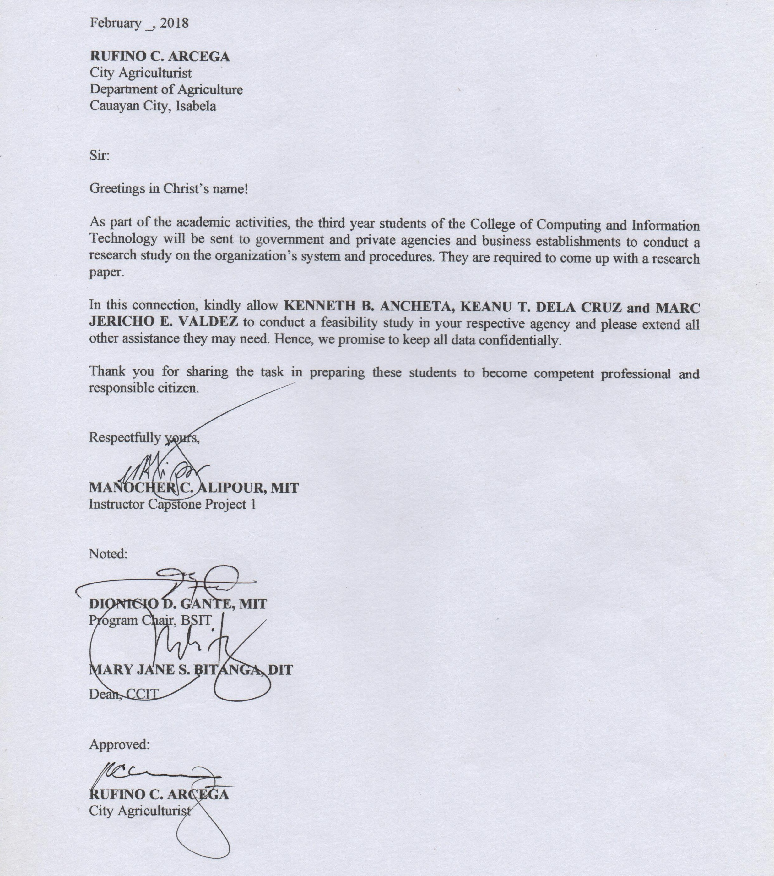

*Appendix D-2 (Working Title Form: Adviser’s Approval letter)*



*Appendix D-3 (Working Title Form: Letter of Beta-Testing)*

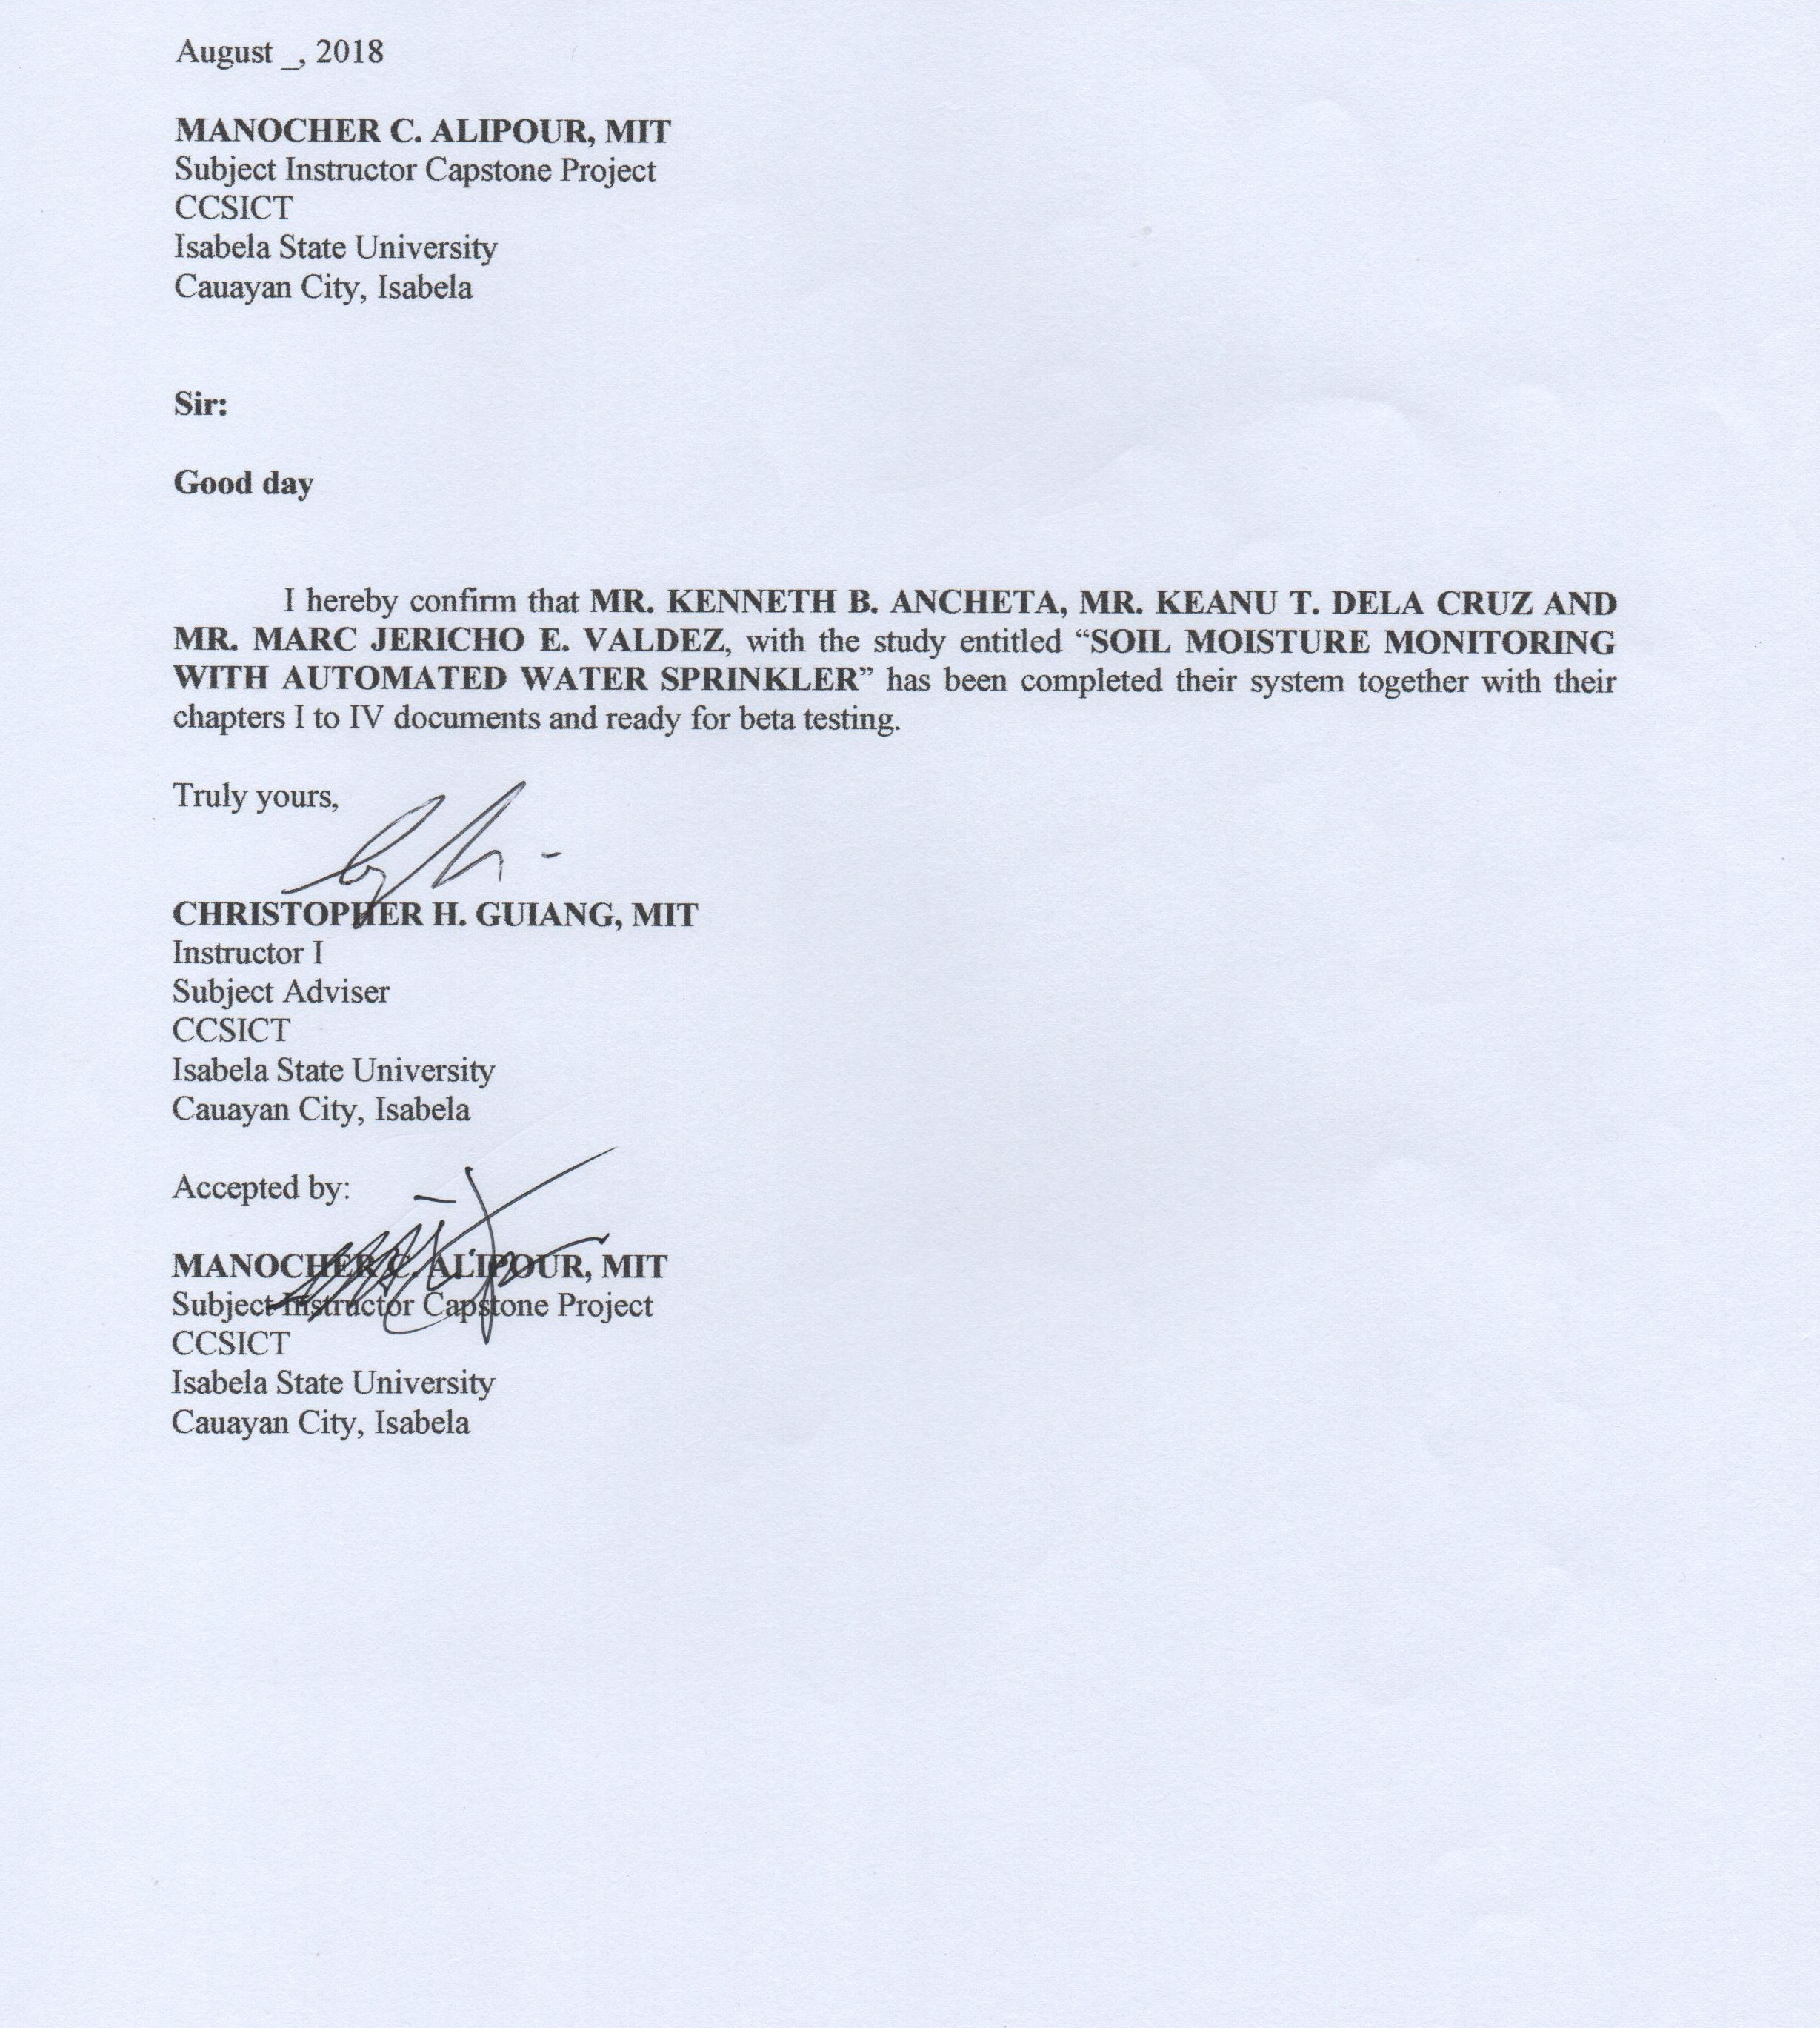

*Appendix D-4 (Working Title Form: Letter of Implementation)*

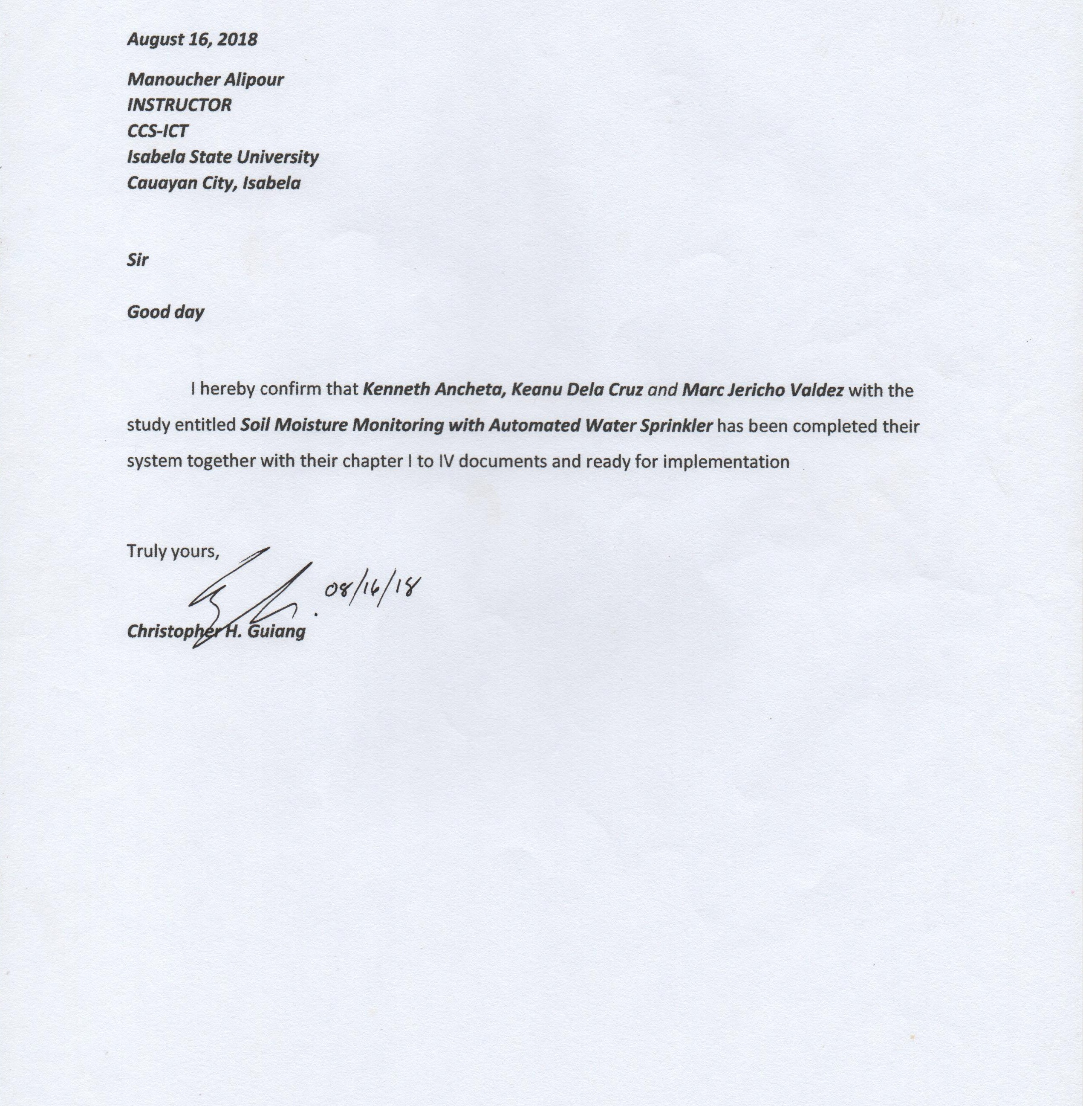

*Appendix D-5 (Working Title Form: Letter to Statistician)*



*Appendix D-6 (Working Title Form: Letter to English Critic)*



*Appendix D-7 (Working Title Form: Nomination of Guidance Committee)*

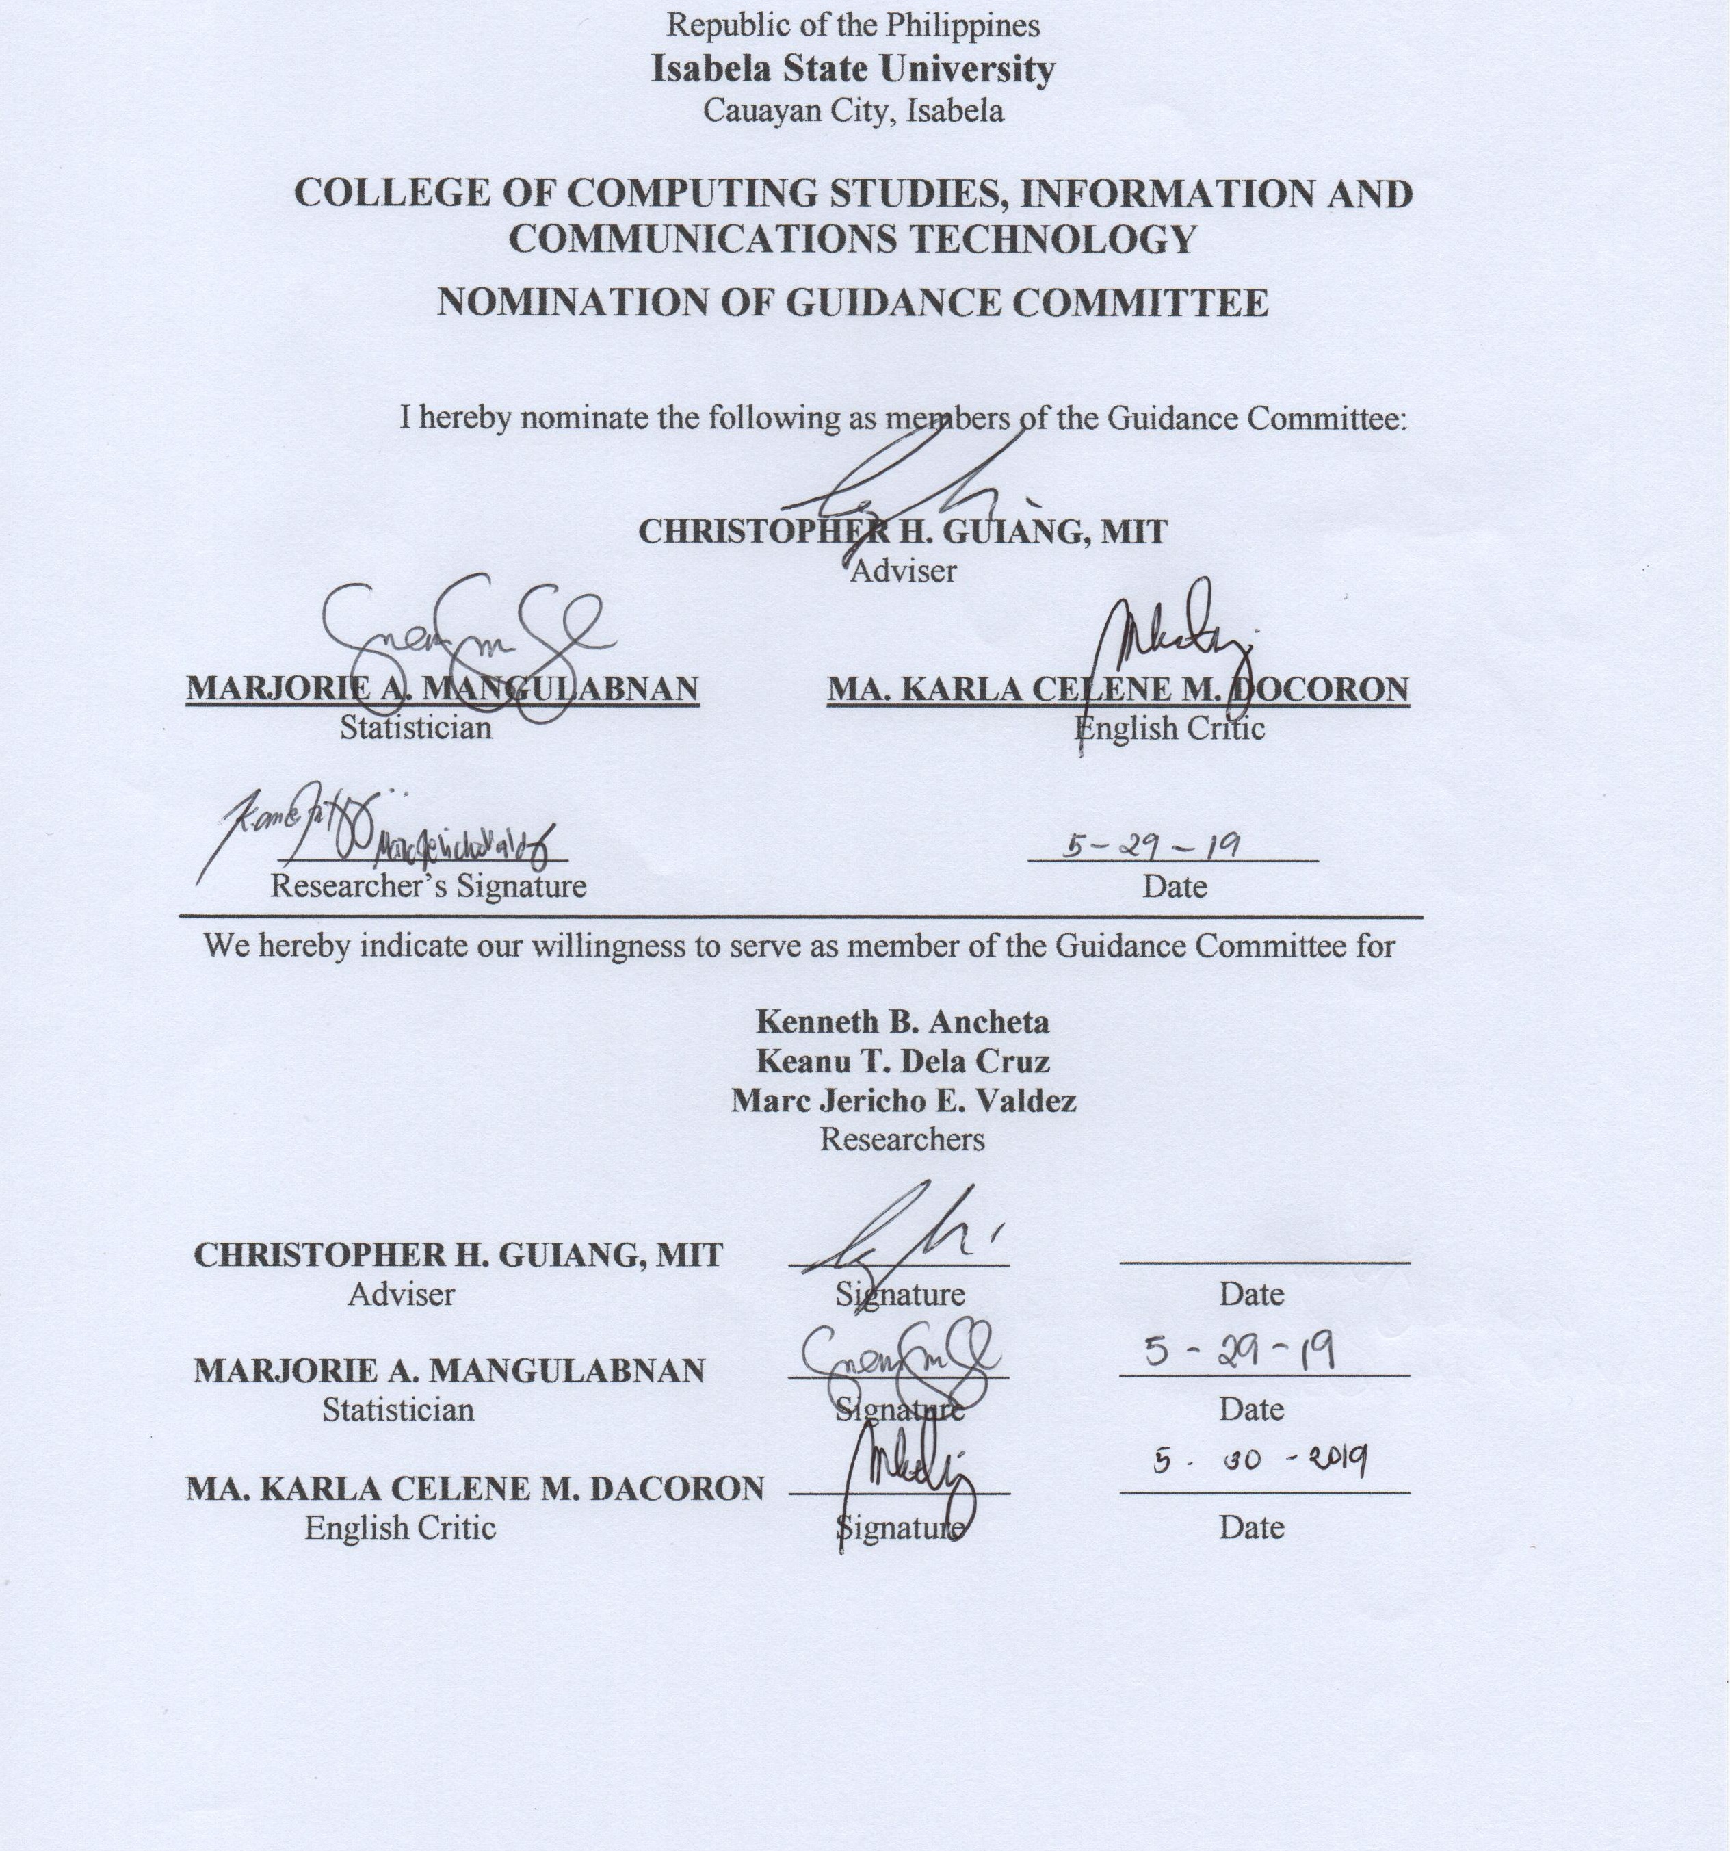

*Appendix E (Grammarian’s Certification)*

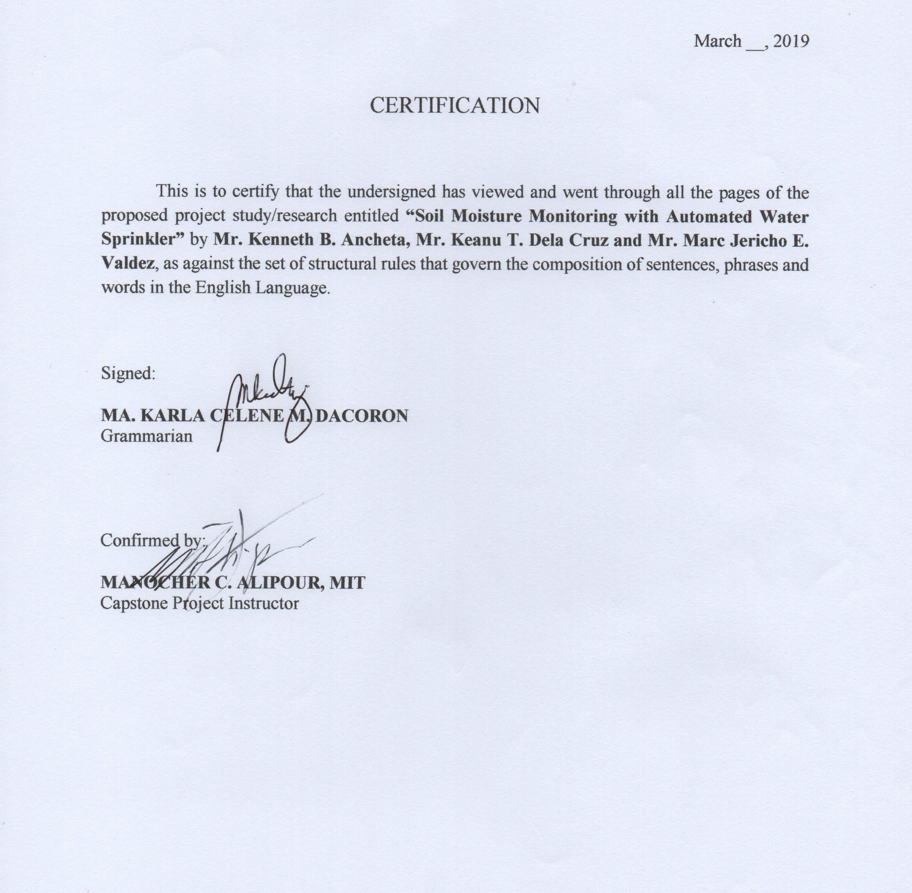

*****Appendix F (Curriculum Vitae)*

**KENNETH B. ANCHETA**

Purok 1, Andarayan, Cauayan City, Isabela (3305)

+63905-7935-856

Kenneth.ancheta01@gmail.com

**CAREER OBJECTIVES**

* To apply professionally the knowledge and skills I’ve learned.
* To enhance my skills and abilities for the benefit of the company.
* To further fulfill the needs and become more productive into the company.

**PERSONAL DATA**

Age: 22 years’ old

Birth Date: August 01, 1996

Civil Status: Single

Weight: 120 lbs.

Height: 5’9”

Religion: Roman Catholic

**EDUCATIONAL BACKGROUND**

Elementary : Andarayan, Bugallon Elementary School

Bugallon, Cauayan City, Isabela

Secondary : Villa Luna National High School

Villa Luna, Cauayan City, Isabela

Tertiary : Isabela State University Cauayan Campus

San Fermin, Cauayan City, Isabela

**SKILLS & ABILITIES**

* Skills in Computer hardware and Software Servicing.
* Knowledgeable in Programming Language (Visual Basic, Php, java, c + +, Arduino Programming)
* Computer Literate: Microsoft Office, Adobe Photoshop.
* Can easily adapt to any working conditions.
* Adept in English, Filipino, and Ilocano Language both Oral and Written.

**ACTIVITIES/SEMINARS ATTENDED**

**Title** : **Capstone Project Training Workshop**

Sponsor : Isabela State University, Cauayan Campus

Venue : Ramon Magsaysay Information Technology Building, Isabela State University, Cauayan Campus

Date : October 11, 2018

**Title** : **Earth Hour 2018, Theme: #Connect2Earth**

Sponsor : Isabela State University Cauayan City Campus

Venue : Isabela State University Cauayan City Campus San Fermin, Isabela

Date : March 24, 2018

**Title** :**2nd International Leadership Training, “Developing Innovative Leadership Skills in a Multicultural Environment”**

Sponsor : Isabela State University Cauayan City Campus

Venue : Boulevard Events Place Cauayan City, Isabela

Date : December 04-05 2017

**Title** : **ISU Wide Resolution and Minutes of the Meetings Seminar**

**Workshop**

Sponsor : Isabela State University Echague Campus

Venue : De Venecia Hall, San Fabian, Echague, Isabela

Date : October 20, 2017

**Title** : **School-based Press Conference**

Sponsor : Villa Luna National High School

Venue : Villa Luna National High School, Cauayan Campus, Cauayan City, Isabela.

Date : November 11, 2011

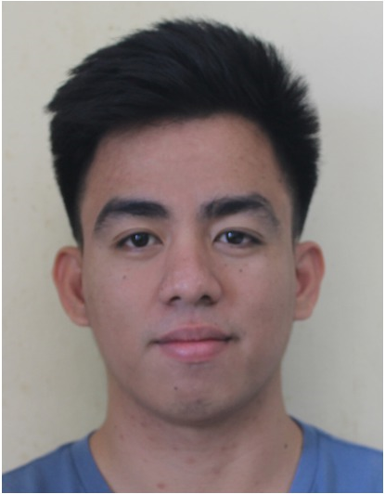

**DELA CRUZ, KEANU TAGUMASI**

Purok Uno, Marabulig 1, Cauayan City, Isabela

+63995-840-6050

dkeanu382016@gmail.com

**CAREER OBJECTIVE**

To apply my skills for developing my career and contribute my abilities for the benefit of the organization.

**PERSONAL DATA**

Gender : Male

Date of Birth : March 03, 1996

Place of Birth : Marabulig 1, Cauayan City

Civil Status : Single

Height : 5’5”

Weight : 53 kg

Religion : Roman Catholic

Father’s Name : Norman Lucas Dela Cruz

Mother’s Name : Salvacion Idmilao Tagumasi

**EDUCATIONAL BACKGROUND**

Elementary : Cauayan South Central School -

Cauayan City

Secondary : Our Lady of Pillar College-

Cauayan - Cauayan City, Isabela

Tertiary : Isabela State University Cauayan

Campus – Cauayan City

**SKLLS AND ABILITIES**

* Knowledge in computer programming (Visual Basic, MySQL, Arduino).
* Reliable to do jobs in any circumstances.
* Hardworking and can work under pressure.

**SEMINARS ATTENDED**

**Title** : **Computer Systems Servicing NC II**

Sponsor : Southern Isabela College of Arts and Trades

Venue : Calaocan, Santiago City

Date : June 6, 2016

**Title** : **General Programming**

Sponsor : Isabela State University Cauayan City Campus

Venue : Isabela State University Cauayan City Campus San Fermin, Isabela

Date : April 27, 2017

**Title** : **ISU Wide Resolution and Minutes of the Meetings Seminar**

**Workshop**

Sponsor : Isabela State University Echague Campus

Venue : De Venecia Hall, San Fabian, Echague, Isabela

Date : October 20, 2017

**Title** : **Sangguniang Kabataan Mandatory Training 2018**

Sponsor : Department of the Interior and Local Training 2018

Venue : Parish Council Hall, Cauayan City, Isabela

Date : May 22, 2018

**Title** : **ARDUINO Training Workshop**

Sponsor : College of Computing Studies, Information and Communications

Technology

Venue : Ramon Magsaysay Information Technology Building, Isabela State

University, Cauayan Campus, Cauayan City, Isabela.

Date : September 21, 2018

**Title** : **Capstone Project Training Workshop**

Sponsor : College of Computing Studies, Information and Communications

Technology

Venue : Ramon Magsaysay Information Technology Building, Isabela State

University, Cauayan Campus, Cauayan City, Isabela.

Date : October 11, 2018

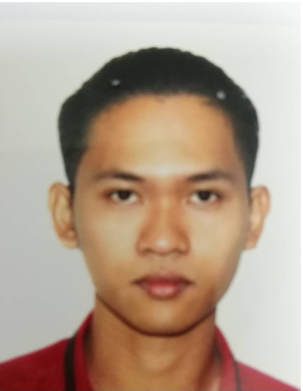

**VALDEZ, MARC JERICHO ESPEJO**

Purok 6, Villa Domingo, Angadanan, Isabela

+63936-275-7377

Vmj121996@gmail.com

**CAREER OBJECTIVE**

To share the ideas that I have learned and work on a challenging environment where I can

contribute my skills for the growth of the organization.

**PERSONAL DATA**

Gender : Male

Date of Birth : March 12, 1996

Place of Birth : Angadanan, Isabela

Civil Status : Single

Height : 5’3”

Weight : 55 kg

Religion : Church of God

Father’s Name : Marlou B. Valdez

Mother’s Name : Jeannaline E. Valdez

**EDUCATIONAL BACKGROUND**

Elementary : Villa Domingo Elementary School

Secondary : Villa Domingo National High School

Angadanan, Isabela

Tertiary : Isabela State University Cauayan

Campus – Cauayan City

**SKLLS AND ABILITIES**

* Knowledge in Graphics Design(photoshop cs6).
* Knowledge in Microsoft Office.
* Can easily adapt to any working conditions that can relible in my passion.

**SEMINARS ATTENDED**

**Title** : **ISU Wide Resolution and Minutes of the Meetings Seminar**

**Workshop**

Sponsor : Isabela State University Echague Campus

Venue : De Venecia Hall, San Fabian, Echague, Isabela

Date : October 20, 2017

**Title** : **Capstone Project Training Workshop**

Sponsor : College of Computing Studies, Information and Communications

Technology

Venue : Ramon Magsaysay Information Technology Building, Isabela State

University, Cauayan Campus, Cauayan City, Isabela.

Date : October 11, 2018

**GLOSSARY**

**Android** - is a mobile operating system develop by Google, based on a modified version of the Linux kernel and other open source software and designed primarily for touchscreen mobile devices such as smartphones and tablets.

**Android Studio** - is the official integrated development environment (IDE) for Google's Android operating system, built on JetBrains' IntelliJ IDEA software.

**Arduino Uno** - is a microcontroller to process the data from measuring the water level using ultrasonic sensor with the collaboration GSM sim 900 to send the data to the server. Broadband– a modem was used to receive the data from the device.

**Arduino -**  is an [open-source hardware](https://en.wikipedia.org/wiki/Open-source_hardware) and [software](https://en.wikipedia.org/wiki/Open-source_software) company, project and user community that designs and manufactures [single-board microcontrollers](https://en.wikipedia.org/wiki/Single-board_microcontroller) and [microcontroller](https://en.wikipedia.org/wiki/Microcontroller) kits for building digital devices and interactive objects that can sense and control objects in the physical and digital world.

**Battery 12V** - converts chemical energy into electrical energy by a chemical reaction.

**Context Diagram** - in engineering is a diagram that defines the boundary between the system, or part of a system, and its environment, showing the entities that interact with it. This diagram is a high-level view of a system. It is similar to a block diagram.

**Dataflow Diagram** - is a graphical representation of the "flow" of data through an information system, modelling its process aspects. ADFD is often used as a preliminary step to create an overview of the system without going into great detail, which can later be elaborated.

**Entity Relationship Diagram** - connection of tables from database to determine the relationships of user.

**Fishbone Diagram** - to identify the problems encountered by the respondent.

**Flowchart** - shows the whole process and procedure of project.

**Functional Decomposition** -  is the process of resolving a [functional](https://en.wikipedia.org/wiki/Function_(mathematics)) relationship into its constituent parts in such a way that the original function can be reconstructed from those parts by [function composition](https://en.wikipedia.org/wiki/Function_composition).

**GSM SIM900A Module** - a chip or circuit that will be used to establish communication between a mobile Device and a computing machine.

**Gantt Chart** - used as a guide to manage schedules in development of the system and writing the documentation.

**Hygrometer** - is an instrument used for measuring the amount of humidity and water vapor in the atmosphere, in soil, or in confined spaces.

**Input Process Output Mode**l - is a widely used approach in [systems analysis](https://en.wikipedia.org/wiki/Systems_analysis) and [software engineering](https://en.wikipedia.org/wiki/Software_engineering) for describing the structure of an information processing program or other process.

**Jumper Wires -** are simply wiring that have connector pins at each end, allowing them to be used to connect two points to each other without soldering.

**Laptop** - use in developing and encoding the programs of the system.

**Likert Scale** - shows the weighted mean range and its descriptive interpretation as evaluated by the respondents.

**Program Flowchart** - was used to show on how the application software flow.

**Relay Module -** are used to control or switch devices which uses a higher power than what most microcontrollers such as an Arduino or Raspberry Pi can handle.

**SMS** - (short message service) is a [text messaging](https://en.wikipedia.org/wiki/Text_messaging) service component of most telephone, internet, and mobile-device systems. It uses standardized [communication protocols](https://en.wikipedia.org/wiki/Communication_protocols) to enable mobile devices to exchange short text messages.

**Survey questionnaire** - is a type of data gathering method that is utilized to collect, analyze and interpret the different views of a group of people from a particular population.

**Solenoid water valve-** valve is an electromechanical device in which the solenoid uses an electric current to generate a magnetic field and thereby operate a mechanism which regulates the opening of fluid flow in a valve.

**SQLite** - is a storage engine include both those that handle transaction-safe tables and those that Handle non-transaction-safe table.

**Testing** - the develop system was tested from the smallest unit to the whole process.

**Water Sprinkler** - is a device used to [irrigate](https://en.wikipedia.org/wiki/Irrigation) agricultural crops, lawns, landscapes, golf courses, and other areas. They are also used for cooling and for the control of airborne dust. Sprinkler irrigation is the method of applying water to a controlled manner in that is similar to rainfall.